STATUTORY RULES.
1939. No. 14.

REGULATION UNDER THE POST AND TELEGRAPH ACT 1901-1934.*
I, THE GOVERNOR-GENERAL in and over the Commonwealth of Australia, acting with the advice of the Federal Executive Council, hereby make the following Regulation under the Post and Telegraph Act 1901-1934.
Dated this twenty second day of February, 1939.
(SGD.) GOWRIE.
Governor-General.
By His Excellency’s Command,
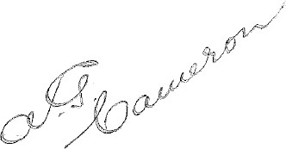
Postmaster-General.

Amendment of the Telegraph Regulations.†
Regulation 77 of the Telegraph Regulations is amended by omitting sub-regulation (2.) and inserting in its stead the following sub-regulation:—
“(2.) Brief particulars consisting of the date of lodgment, charge, name of addressee and telegraph office of destination (or telegraph office of origin in the case of messages telephoned to subscribers) in respect of each telegram covered by the charges included in his account may be furnished to the telephone subscriber on request, subject to payment of a fee for each such statement calculated on the basis of a charge of one shilling for particulars of not more than twenty-five telegrams, sixpence for each additional group of twenty-five telegrams or portion thereof up to an inclusive total of 200, and thereafter sixpence for each additional group of fifty telegrams or portion thereof. A certified copy of any telegram referred to in the statement may be obtained in accordance with the provisions of regulation 68 of these Regulations.”

*Notified in Commonwealth Gazette on , 1939
†Statutory Rules 1927, No. 142, as amended by Statutory Rules 1928, Nos. 35, 88, 97; 1929, Nos. 15, 128; 1930, Nos. 1, 5, 42, 81, 114, 129; 1931, Nos. 70, 132, 136; 1933, Nos. 102, 127; 1934. Nos. 24, 113, 137; 1935, No. 77, and 1938, No. 63.

By Authority: L. F. Johnston, Commonwealth Government Printer, Canberra.
404.—8/31.1.1939.—Price 3d.

