STATUTORY RULES.
1939. No. 84.

REGULATION UNDER THE POST AND TELEGRAPH ACT 1901-1934.
I, THE GOVERNOR-GENERAL in and over the Commonwealth of Australia, acting with the advice of the Federal Executive Council, hereby make the following Regulation under the Post and Telegraph Act 1901-1934.
Dated this sixth day of September, 1939.
Governor-General.
By His Excellency’s Command,
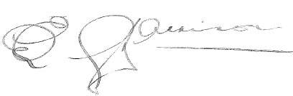
Postmaster-General.

Amendment of the Telegraph Regulations.†
Regulation 59 of the Telegraph Regulations is repealed.
* Notified in the Commonwealth Gazette on , 1939.
† Statutory Rules 1927, No. 142, as amended by Statutory Rules 1928, Nos. 35, 88, 97; 1929, Nos. 15, 128; 1930, Nos. 1, 5, 42, 81, 114, 129; 1931, Nos. 70, 132, 136; 1933, Nos. 102, 127; 1934, Nos. 24, 113, 137; 1935, No. 77; 1938, No. 63; and 1939, No. 14.

By Authority: L. F. Johnston, Commonwealth Government Printer, Canberra.
4133.—8/21.8.1939.—Price 3d.

