STATUTORY RULES.
1947. No. 27.

REGULATION UNDER THE COMMONWEALTH EMPLOYEES’ COMPENSATION ACT 1930-1944.*
I, THE ADMINISTRATOR of the Government of the Commonwealth of Australia, acting with the advice of the Federal Executive Council, hereby make the following Regulation under the Commonwealth Employees’ Compensation Act 1930-1944.
Dated this twentysixth day of February, 1947.
W. DUGAN
Administrator.
By His Excellency’s Command,
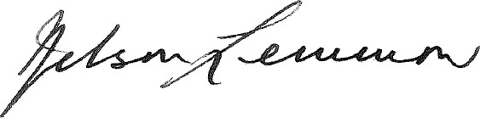
Treasurer.

Amendment of the Employees’ Compensation Regulations.†
Commonwealth Authorities.
Regulation 14 of the Employees’ Compensation Regulations is amended by adding at the end thereof the following words:—
“Overseas Telecommunications Commission.”.

* Notified in the Commonwealth Gazette on , 1947.
† Statutory Rules 1945, No. 23, as amended by Statutory Rules 1946, No. 37.

By Authority: L. F. Johnston, Commonwealth Government Printer, Canberra.
826.—PRicE 3d. 9/6.2.1947.

