STATUTORY RULES.
1947. No .

REGULATIONS UNDER THE IMMIGRATION ACT 1901-1940.*
I, THE GOVERNOR-GENERAL in and over the Commonwealth of Australia, acting with the advice of the Federal Executive Council, hereby make the following Regulations under the Immigration Act 1901-1940.
Dated this nineteenth day of November, 1947.
W. J. McKell
Governor-General.
By His Excellency’s Command,
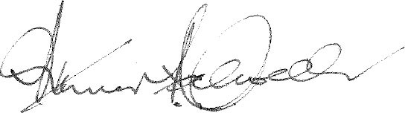
Minister of State for Immigration
———
Amendments of the Immigration Regulations.†
Immigrants to furnish statements.
1. Regulation 4 of the Immigration Regulations is amended—
(a) by omitting sub-regulation (1.) and inserting in its stead the following sub-regulation:—
“(1.) A passenger shall, on arrival at the first airport or port of call in Australia, furnish to an officer a passenger card, duly completed and signed, in accordance with a form approved by the Minister.”.
(b) by omitting from sub-regulation (2.) the word “statement” and inserting in its stead the words “passenger card”;
(c) by omitting sub-regulation (3.) and inserting in its stead the following sub-regulation:—
“(3.) A passenger who makes a false statement in supplying information required by a passenger card, or presents to an officer a passenger card which is false in any particular, shall be guilty of an offence against these Regulations.”.
(d) by omitting paragraph (b) of sub-regulation (4.).
Landing permits.
2. Regulation 5 of the Immigration Regulations is amended—
(a) by omitting from sub-regulation (2.) the word “A” and inserting in its stead the words “Subject to the next succeeding sub-regulation, a” ; and
(b) by inserting after that sub-regulation the following sub-regulation :—
“(2a.) The Minister may, if he thinks fit, cancel a landing permit at any time.”.
* Notified in the Commonwealth Gazette on , 1947.
† Statutory Rules 1932, No. 103, as amended by Statutory Rules; 1933, No. 128; 1940, No. 144; 1941, No. 66; and 1946, No. 20.
3829.—Price 3d. 8/28.10.1947.

Re-entry permits.
3. Regulation 13 of the Immigration Regulations is amended—
(a) by omitting from sub-regulation (2.) the words “on payment of the prescribed fee” ; and
(b) by omitting sub-regulation (3.).
The Schedule.
4. The Schedule to the Immigration Regulations is amended—
(a) by omitting Form A; and
(b) by omitting from item 14 in Form F the words “fee of One pound and”.

By Authority: L. F. Johnston, Commonwealth Government Printer, Canberra.

