STATUTORY RULES.
1948. No. 33.

REGULATION UNDER THE DEFENCE ACT 1903-1947.*
I, THE GOVERNOR-GENERAL in and over the Commonwealth of Australia, acting with the advice of the Federal Executive Council, hereby make the following Regulation under the Defence Act 1903-1947.
Dated this third day of March, 1948.
W. J. McKell
Governor-General.
By His Excellency’s Command,
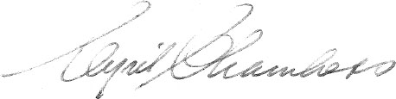
Minister of State for the Army.

Amendment of Royal Military College Regulations.†
Dates of examinations and admissions.
1. Regulation 11 of the Royal Military College Regulations is amended by omitting sub-regulation (3.) and inserting in its stead the following sub-regulation :—
“(3.) Candidates for normal entry who are selected for admission as students shall join on the Saturday nearest to the fifteenth day of February or on such other day as the Military Board from time to time directs.”.

* Notified in the Commonwealth Gazette on , 1948.
† Statutory Rules 1939, No. 7, as amended by Statutory Rules 1939, No. 94; 1941, No. 24; 1943, No. 70; and 1946, No. 160.

By Authority: L. F. Johnston, Commonwealth Government Printer, Canberra.
531.—Price 3d. 10/28.1.1948.

