STATUTORY RULES.
1949. No. .

REGULATION UNDER THE DEFENCE ACT 1903-1948.*
I, THE GOVERNOR-GENERAL in and over the Commonwealth of Australia, acting with the advice of the Federal Executive Council, hereby make the following Regulation under the Defence Act 1903-1948.
Dated this twenty-ninth day of September, 1949.
W. J. McKell
Governor-General.
By His Excellency’s Command,
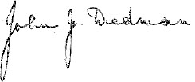
Minister of State for Defence.

Repeal of the Civilian Staff Regulations.
Repeal.
The Civilian Staff Regulations (being Statutory Rules 1926, No. 209, as amended) are repealed.

* Notified in the Commonwealth Gazette on , 1949.

By Authority: L. F. Johnston, Commonwealth Government Printer, Canberra.
3903.—Price 3d. 12/8.8.1949.

