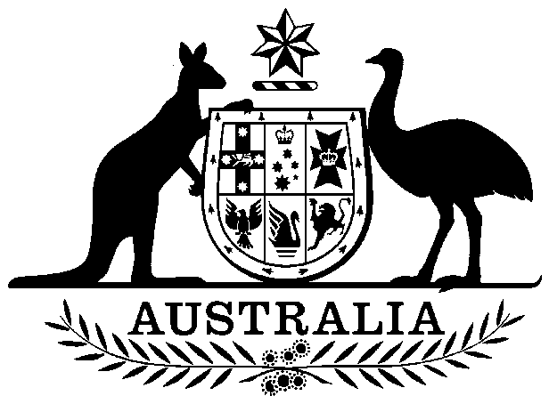
Flags Act 1953
Act No. 1 of 1954 as amended
This compilation was prepared on 20 February 2001
taking into account amendments up to Act No. 2 of 1998
The text of any of those amendments not in force
on that date is appended in the Notes section
Prepared by the Office of Legislative Drafting,
Attorney-General’s Department, Canberra

Contents
1 Short title [see Note 1] 1
2 Extension to Territories 1
3 The Australian National Flag 1
4 The Australian Red Ensign 2
5 Other flags 2
6 Warrants to use flags 2
7 Rules as to use of flags 2
8 Flying of Union Jack 2
Schedule 1—The Australian National Flag and the Australian Red Ensign 3
Schedule 2—Flags 5
Notes 7

An Act to declare a certain Flag to be the Australian National Flag and to make other provision with respect to Flags

1 Short title [see Note 1]
This Act may be cited as the Flags Act 1953.

2 Extension to Territories
This Act extends to all the Territories.

3 The Australian National Flag
(1) The blue flag described in Schedule 1, being the flag a reproduction of which is set out in Part I of Schedule 2, is declared to be the Australian National Flag.
(2) The blue flag referred to in subsection (1) ceases to be the Australian National Flag if, and only if:
(a) a new flag or flags, and the flag referred to in subsection (1), are submitted in each State and Territory to the electors qualified to vote for the election of members of the House of Representatives; and
(b) the new flag, or one of the new flags, is chosen by a majority of all the electors voting.
(3) The form and manner in which a proposal for a new Australian National Flag is submitted to electors, and the manner in which a vote on the proposal is taken (which may include the adoption of a form of preferential voting for choosing among 3 or more flags), and arrangements for adopting a new flag as the Australian National Flag if chosen as mentioned in subsection (2), are to be as the Parliament prescribes.
(4) In this section:
Territory means any Territory referred to in section 122 of the Constitution in respect of which there is in force a law allowing its representation in the House of Representatives.

4 The Australian Red Ensign
The red flag described in Schedule 1, being the flag a reproduction of which is set out in Part II of Schedule 2, shall be known as the Australian Red Ensign.

5 Other flags
The Governor-General may, by Proclamation, appoint such other flags and ensigns of Australia as he thinks fit.

6 Warrants to use flags
The Governor-General may, by warrant, authorize a person, body or authority to use a flag or ensign referred to in, or appointed under, this Act, either without defacement or defaced in the manner specified in the warrant.

7 Rules as to use of flags
The Governor-General may make, and cause to be published, rules for the guidance of persons in connexion with the flying or use of flags or ensigns referred to in, or appointed under, this Act.

8 Flying of Union Jack
This Act does not affect the right or privilege of a person to fly the Union Jack.

Schedule 1—The Australian National Flag and the Australian Red Ensign
Sections 3 and 4
1. The Australian National Flag is a blue flag, and the Australian Red Ensign is a red flag, the design of each of which is specified in clause 1A.
1A. Each of the flags referred to in clause 1 has:
(a) the Union Jack occupying the upper quarter next the staff;
(b) a large white star (representing the 6 States of Australia and the Territories) in the centre of the lower quarter next the staff and pointing direct to the centre of St George’s Cross in the Union Jack, as specified in Table A; and
(c) 5 white stars (representing the Southern Cross) in the half of the flag further from the staff, as specified in Table B.
Table A—Commonwealth Star
Position of Centre | Outer Diameter | Inner Diameter | Number of Points
On middle line (parallel with the hoist edge of flag) of Union Jack (produced), one-quarter width of flag from bottom edge of flag | Three-tenths of width of flag | Four-ninths of outer diameter | Seven

Table B—Stars of the Southern Cross
 | Position of Centre | Outer Diameter | Inner Diameter | Number
Name | The fractions are fractions of  width of flag |  | In fractions of outer diameter | of  Points
Alpha Crucis | On middle line, one-sixth from bottom edge | One-seventh | Four-ninths | Seven
Beta Crucis | One-quarter from middle line, at right angles on left to a point on middle line one-sixteenth above centre of fly | One-seventh | Four-ninths | Seven
Gamma Crucis | On middle line one-sixth from top edge | One-seventh | Four-ninths | Seven
Delta Crucis | Two-ninths from middle line at right angles on right to a point one-fifteenth above a point on middle line one-sixteenth above centre of fly | One-seventh | Four-ninths | Seven
Epsilon Crucis | One-tenth from middle line at right angles on right to a point on middle line one twenty-fourth below centre of fly | One-twelfth | Four-ninths | Five
2. In Table A and Table B, “width of flag” means the measurement of the hoist edge of the flag.
3. In Table B, “middle line” means a straight line, parallel with the hoist edge of the flag, and dividing the fly into two equal parts.

Schedule 2—Flags
Sections 3 and 4
Part I

AUSTRALIAN NATIONAL FLAG

Part II

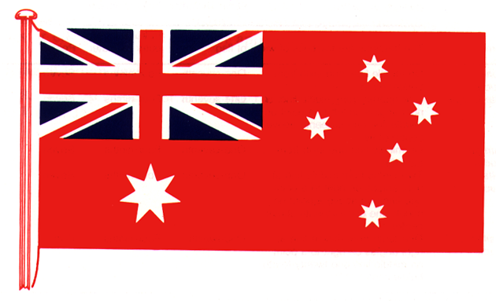
AUSTRALIAN RED ENSIGN

Notes to the Flags Act 1953
Note 1
The Flags Act 1953 as shown in this compilation comprises Act No. 1, 1954 amended as indicated in the Tables below.
Table of Acts
Act | Number  and year | Date  of Assent | Date of commencement | Application, saving or transitional provisions
Flags Act 1953 | 1, 1954 | 14 Feb 1954 | 14 Apr 1954 (a)
Flags Act 1954 | 58, 1954 | 6 Nov 1954 | 14 Apr 1954 | —
Statute Law Revision Act 1973 | 216, 1973 | 19 Dec 1973 | 31 Dec 1973 | Ss. 9(1) and 10
Flags Amendment Act 1981 | 9, 1981 | 25 Mar 1981 | 26 Jan 1982 (see s. 2 and Gazette 1981, No. G51,  p. 2) | —
Flags Amendment Act 1998 | 2, 1998 | 24 Mar 1998 | 24 Mar 1998 | —

(a) This Act was reserved for Her Majesty’s pleasure on 12 December 1953, the Queen’s Assent was given on 14 February 1954 and was made known to each House of the Parliament on 15 February 1954. By a Proclamation dated 8 April 1954, the Queen’s Assent was proclaimed in the Gazette on 14 April 1954 (see Gazette 1954, p. 1179).
Table of Amendments
ad. = added or inserted am. = amended rep. = repealed rs. = repealed and substituted
Provision affected | How affected
S. 2 | am. No. 216, 1973
S. 3 | rs. No. 9, 1981
 | am. No. 2, 1998
S. 4 | rs. No. 9, 1981
S. 7 | am. No. 216, 1973
Heading to the Schedules | rep. No. 9, 1981
Heading to First Schedule | rep. No. 9, 1981
First Schedule | am. No. 58, 1954; No. 216, 1973
Heading to Schedule 1 | ad. No. 9, 1981
Schedule 1 | am. No. 9, 1981
Heading to Second Schedule | rep. No. 9, 1981
Heading to Schedule 2 | ad. No. 9, 1981

