FLAGS.

**No. 1 of 1954.**

An Act to declare a certain Flag to be the Australian National Flag and to make other provision with respect to Flags.

[Reserved for Her Majesty’s pleasure, 12th December, 1953.]

[Queen’s Assent, 14th February, 1954.]

[Queen’s Assent made known to each House of the Parliament, 15th February, 1954.]

BE it enacted by the Queen’s Most Excellent Majesty, the Senate, and the House of Representatives of the Commonwealth of Australia, as follows:—

**Short title.**

**1.** This Act may be cited as the *Flags Act* 1953.

**Extension to Territories.**

**2.** This Act extends to all the Territories of the Commonwealth.

**The Australian National Flag.**

**3.** The flag described in the First Schedule to this Act, being the flag a reproduction of which is set out in Part I. of the Second Schedule to this Act, is declared to be the Australian National Flag.

**The Australian Red Ensign.**

**4.**—(1.) The flag which is declared by section four hundred and six of the *Navigation Act* 1912-1953 to be the proper colours for merchant ships registered in Australia, being the flag a reproduction of which is set out in Part II. of the Second Schedule to this Act, shall be known as the Australian Red Ensign.

(2.) The descriptions and positions of the stars which form part of the design of the Australian Red Ensign shall be the same as the descriptions and positions of those stars as forming part of the design of the Australian National Flag.

**Other flags.**

**5.** The Governor-General may, by Proclamation, appoint such other flags and ensigns of Australia as he thinks fit.

**Warrants to use flags.**

**6.** The Governor-General may, by warrant, authorize a person, body or authority to use a flag or ensign referred to in, or appointed under, this Act, either without defacement or defaced in the manner specified in the warrant.

**Rules as to use of flags.**

**7.** The Governor-General may make, and cause to be published, rules for the guidance of persons in connexion with the flying or use of flags referred to in, or appointed under, this Act.

**Flying of Union Jack.**

**8.** This Act does not affect the right or privilege of a person to fly the Union Jack.

THE SCHEDULES.

FIRST SCHEDULE. Section 3.

THE AUSTRALIAN NATIONAL FLAG.

**1.** The Australian National Flag is the British Blue Ensign, consisting of a blue flag with the Union Jack occupying the upper quarter next the staff, differenced by a large white star (representing the six States of Australia and the Territories of the Commonwealth) in the centre of the lower quarter next the staff and pointing direct to the centre of the St. George’s Cross in the Union Jack and five white stars, representing the Southern Cross, in the fly, or half of the flag further from the staff. The descriptions and positions of the stars are in accordance with the following tables:—

TABLE A.

Commonwealth Star.

|  |  |  |  |
| --- | --- | --- | --- |
| Position of Centre. | Outer Diameter. | Inner Diameter. | Number of Points. |
| On middle line (parallel with the hoist edge of flag) of Union Jack (produced), one-quarter width of flag from bottom edge of flag | Three-eighths of width of flag | Four-ninths of outer diameter | Seven |

TABLE B.

Stars of the Southern Cross.

|  |  |  |  |  |
| --- | --- | --- | --- | --- |
| Name. | Position of Centre. | Outer Diameter. | Inner Diameter. | Number of Points. |
| The fractions are fractions of width of flag. | | In fractions of outer diameter. |
| *Alpha Crucis* | On middle line, one-sixth from bottom edge | One-seventh | Four-ninths | Seven |
| *Beta Crucis* | One-quarter from middle line, at right angles on left to a point on middle line one-sixteenth above centre of fly | One-seventh | Four-ninths | Seven |
| *Gamma Crucis* | On middle line one-sixth from top edge | One-seventh | Four-ninths | Seven |
| *Delta Crucis* | Two-ninths from middle line at right angles on right to a point one-fifteenth above a point on middle line one-sixteenth above centre of fly | One-seventh | Four-ninths | Seven |
| *Epsilon Crucis* | One-tenth from middle line at right angles on right to a point on middle line one twenty-fourth below centre of fly | One-twelfth | Four-ninths | Five |

**2.** In Table A and Table B, “width of flag” means the measurement of the hoist edge of the flag.

**3.** In Table B, “middle line” means a straight line, parallel with the hoist edge of the flag, and dividing the fly into two equal parts.

SECOND SCHEDULE.

Part I.

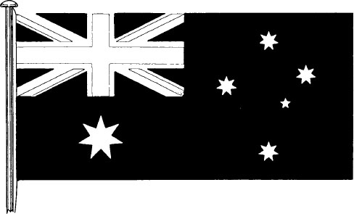

**AUSTRALIAN NATIONAL FLAG**

Part II.

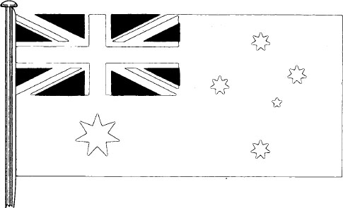

**AUSTRALIAN RED ENSIGN**