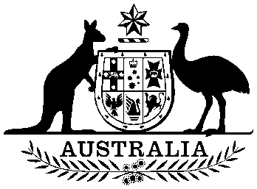

Nauru Independence Act 1967

No. 103 of 1967

An Act relating to Nauru

Contents

1 Short title 1

2 Commencement 1

3 Power of the Legislative Council for Nauru to provide for the establishment of a constitutional convention 2

4 Australia to cease to be responsible for government of Nauru 2



Nauru Independence Act 1967

No. 103 of 1967

An Act relating to Nauru

[*Assented to 10 November 1967*]

The Parliament of Australia enacts:

1 Short title

This Act may be cited as the *Nauru Independence Act 1967*.

2 Commencement

(1) Sections 1, 2 and 3 of this Act shall come into operation on the day on which this Act receives the Royal Assent.

(2) Section 4 of this Act shall come into operation on a date to be fixed by Proclamation, in this Act referred to as “Nauru Independence Day”.

3 Power of the Legislative Council for Nauru to provide for the establishment of a constitutional convention

The power of the Legislative Council for the Territory of Nauru conferred by section 26 of the *Nauru Act 1965* to make Ordinances for the peace, order and good government of that Territory extends to the making of an Ordinance establishing a convention for the purpose of establishing a constitution for Nauru.

4 Australia to cease to be responsible for government of Nauru

(1) On the expiration of the day preceding Nauru Independence Day:

(a) the *Nauru Act 1965* is repealed; and

(b) all acts that extend to Nauru as a Territory of the Commonwealth cease so to extend.

(2) On and after Nauru Independence Day, Australia shall not exercise any powers of legislation, administration or jurisdiction in and over Nauru.