STATUTORY RULES
1972 No.

REGULATIONS UNDER THE NATIONAL URBAN AND REGIONAL DEVELOPMENT AUTHORITY ACT 1972.*
I, THE GOVERNOR-GENERAL in and over the Commonwealth of Australia, acting with the advice of the Federal Executive Council, hereby make the following Regulations under the National Urban and Regional Development Authority Act 1972.
Dated this second day of November, 1972.
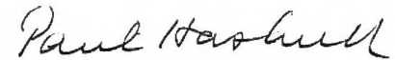

Governor-General.
By His Excellency’s Command,
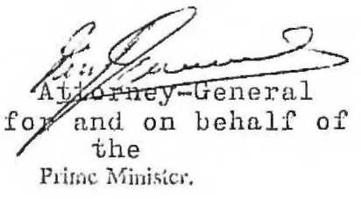
Attorney-General for and on behalf of the Prime Minister.

NATIONAL URBAN AND REGIONAL DEVELOPMENT AUTHORITY REGULATIONS

Citation.
1. These Regulation may be cited as the National Urban and Regional Development Authority Regulations.

Salary of the Commissioner and the Deputy Commissioner.
2. In respect of any period of office before the first day of January, 1974—
(a) there is payable in the Commissioner salary at the rate of Twenty-two thousand seven hundred and fifty dollars per year and an annual allowance at the rate of One thousand five hundred dollars per year; and
(b) there is payable to the Deputy Commissioner salary at the rate of Eighteen thousand nine hundred and seventy-three dollars per year.

Travelling allowance.
3.—(1.) Subject to the next succeeding regulation, where the Commissioner or the Deputy Commissioner is necessarily absent from Canberra overnight in the course of performing his duties, travelling allowance is payable to him in accordance with this regulation.
(2.) Travelling allowance in respect of a period of absence is payable to the Commissioner at the rate of Thirty-four dollars per day and to the Deputy Commissioner at the rate of Twenty-five dollars per day.
(3.) Travelling allowance payable under this regulation is in addition to, and does not include, the cost of conveyance.

Allowances in respect of service outside Australia.
4.—(1.) Where the Commissioner or the Deputy Commissioner performs duties outside Australia and the Territories of the Commonwealth, he is entitled to be paid such allowances as he would be entitled to be paid—
(a) in the case of the Commissioner—if he were the Permanent Head of a Department and in receipt of salary equal to the salary payable to the Secretary to the Department of the Prime Minister and Cabinet; or

* Notified in the Commonwealth Gazette on 1972.
21167/72—Price 5c 10/24.10.1972
(b) in the case of the Deputy Commissioner—if he were an officer of the Public Service of the Commonwealth and were included in the Second Division.
(2.) Where the Commissioner or the Deputy Commissioner is entitled to be paid travelling allowance in respect of a period under the last preceding sub-regulation, he is not entitled to be paid travelling allowance in respect of that period under the last preceding regulation.
Printed by Authority by the Government Printer of the Commonwealth of Australia

