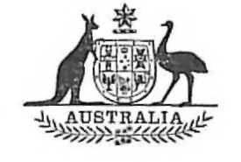
Statutory Rules
1973 No. 85
REGULATIONS UNDER THE TRADE COMMISSIONERS ACT 1933-1936.*
I, THE GOVERNOR-GENERAL in and over the Commonwealth of Australia, acting with the advice of the Federal Executive Council, hereby make the following Regulations under the Trade Commissioners Act 1933-1936.
Dated this fourth day of May, 1973.
PAUL HASLUCK
Governor-General.
By His Excellency’s Command,
J. F. CAIRNS
Minister of State for Overseas Trade.

Amendments of the Trade Commissioners Regulations†
Interpretation.
1. Regulation 3 of the Trade Commissioners Regulations is amended by omitting the definition of “the Department” and substituting the following definition:—
“‘the Department’ means the Department of Overseas Trade;”.
Recreation leave.
2. (1) Regulation 14 of the Trade Commissioners Regulations is amended by omitting the word “three” and substituting the word “four”.
(2) The amendment effected by sub-regulation (1) applies to and in relation to a year of service of a Commissioner ending on or after the first day of January, 1973, and to each subsequent year of service.

* Notified in the Commonwealth Gazette on 10 May 1973.
† Statutory Rules 1958, No. 52, as amended by Statutory Rules 1958, No. 74; 1959, No. 92; 1960, No. 45; 1961, Nos. 37 and 38; 1962, Nos. 43 and 80; 1964, No. 116; 1966, No. 19; 1967, No. 55; 1969, No. 89; 1971, No. 36; and 1973, No. 52.

