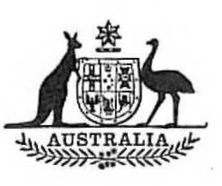
Statutory Rules
1973 No. 244
REGULATIONS UNDER THE HIGH COMMISSIONER (UNITED KINGDOM) ACT 1909-1966.*
I, THE GOVERNOR-GENERAL of Australia, acting with the advice of the Executive Council, hereby make the following Regulations under the High Commissioner (United Kingdom) Act 1909-1966.
Dated this twenty-seventh day of November, 1973.
PAUL HASLUCK
Governor-General.
By His Excellency’s Command,
D. R. WILLESEE
Minister of State for Foreign Affairs.

Amendments of the High Commissioner (Staff) Regulations†
Recreation leave.
1. Regulation 50 of the High Commissioner (Staff) Regulations is amended by omitting from sub-regulations (1) and (19) the word “ three ” and substituting the word “ four ”.
Application.
2. The amendments effected by regulation 1 apply to and in relation to recreation leave that accrued or accrues to an officer or employee on or after 1 January 1973.

* Notified in the Australian Government Gazette on 23 November 1973.
† Statutory Rules 1960, No. 87, as amended by Statutory Rules 1965, No. 87; 1966, No. 76; 1967, Nos. 29 and 79; 1968, Nos. 21, 103, 128 and 164; 1969, Nos. 74, 130 and 192; 1970, Nos. 91,146, 215 and 216; 1971, Nos. 81, 110 and 151; 1972, Nos. 22, 68 and 77; and 1973, No. 71 and 177.

