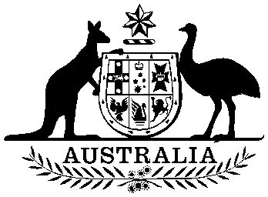

Royal Style and Titles Act 1973

No. 114 of 1973

An Act relating to the Royal Style and Titles



Royal Style and Titles Act 1973

No. 114 of 1973

An Act relating to the Royal Style and Titles

[*Reserved for Her Majesty’s pleasure, 14 September 1973*]

[*Queen’s Assent, 19 October 1973*]

[*Queen’s Assent proclaimed, 19 October 1973*]

WHEREAS, in accordance with the *Royal Style and Titles Act* 1953, Her Majesty, by Proclamation dated 28th May, 1953, adopted, as the Royal Style and Titles to be used in relation to the Commonwealth of Australia and its Territories, the Style and Titles set forth in the Schedule to that Act:

AND WHEREAS the Government of Australia considers it desirable to propose to Her Majesty a change in the form of the Royal Style and Titles to be used in relation to Australia and its Territories:

AND WHEREAS the proposed new Style and Titles, being the Style and Titles set forth in the Schedule to this Act, retains the common element referred to in the preamble to the *Royal Style and Titles Act* 1953:

BE IT THEREFORE enacted by the Queen, the Senate and the House of Representatives of Australia, as follows:

1 Short title

This Act may be cited as the *Royal Style and Titles Act* 1973.

2 Assent to adoption of new Royal Style and Titles in relation to Australia

(1) The assent of the Parliament is hereby given to the adoption by Her Majesty, for use in relation to Australia and its Territories, in lieu of the Style and Titles set forth in the Schedule to the *Royal Style and Titles Act* 1953, of the Style and Titles set forth in the Schedule to this Act, and to the issue for that purpose by Her Majesty of Her Royal Proclamation under such seal as Her Majesty by Warrant appoints.

(2) The Proclamation referred to in sub-section (1) shall be published in the *Gazette* and shall have effect on the date upon which it is so published.

Schedule—Royal Style and Titles

Section 2

Elizabeth the Second, by the Grace of God Queen of Australia and Her other Realms and Territories, Head of the Commonwealth.