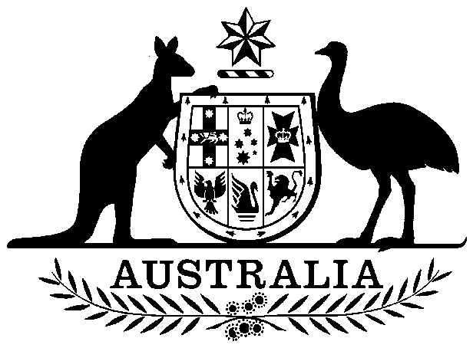

Privy Council (Appeals from the High Court) Act 1975

No. 33 of 1975

An Act to limit further the matters in which Special Leave of Appeal from the High Court of Australia to Her Majesty in Council may be asked

Contents

1 Short title 1

2 Commencement 2

3 Further limitation of matters in which special leave of appeal from the High Court may be asked 2



Privy Council (Appeals from the High Court) Act 1975

No. 33 of 1975

An Act to limit further the matters in which Special Leave of Appeal from the High Court of Australia to Her Majesty in Council may be asked

[*Assented to 30 April 1975*]

The Parliament of Australia enacts:

##### 1 Short title

This Act may be cited as the *Privy Council (Appeals from the High Court) Act 1975*.

##### 2 Commencement

This Act shall come into operation on a date to be fixed by Proclamation, being a date after the date on which the Governor‑General makes known under section 60 of the Constitution that this Act has received the Queen’s assent.

##### 3 Further limitation of matters in which special leave of appeal from the High Court may be asked

Special leave of appeal to Her Majesty in Council from a decision of the High Court shall not be asked in a matter in which such special leave of appeal could, but for this Act, have been asked in accordance with section 3 of the *Privy Council (Limitations of Appeals) Act 1968‑1973* unless the decision of the High Court was given in a proceeding that was commenced in a court before the date of commencement of this Act.