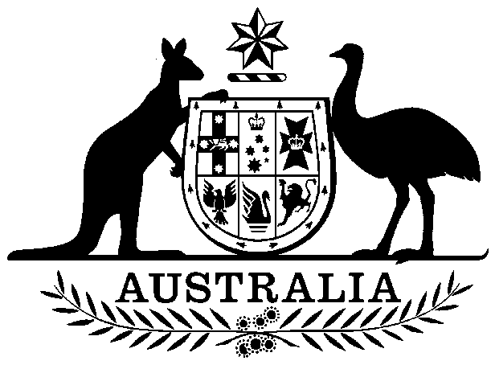

Cheques and Payment Orders Amendment (Turnback of Cheques) Act 1998

No. 77, 1998

Cheques and Payment Orders Amendment (Turnback of Cheques) Act 1998

No. 77, 1998

An Act to amend the Cheques and Payment Orders Act 1986

Contents
1 Short title
2 Commencement
3 Schedule(s)
Schedule 1—Amendment of the Cheques and Payment Orders Act 1986 relating to turnback of cheques drawn on failed banks

Cheques and Payment Orders Amendment (Turnback of Cheques) Act 1998
No. 77, 1998

An Act to amend the Cheques and Payment Orders Act 1986
[Assented to 2 July 1998]
The Parliament of Australia enacts:

1 Short title
This Act may be cited as the Cheques and Payment Orders Amendment (Turnback of Cheques) Act 1998.

2 Commencement
(1) Subject to this section, this Act commences on the day on which it receives the Royal Assent.
(2) Subject to subsection (3), the items of Schedule 1, other than item 6, commence on a day to be fixed by Proclamation.
(3) If the items to which subsection (2) applies do not commence under subsection (2) within the period of 6 months beginning on the day on which this Act receives the Royal Assent, they commence on the first day after the end of that period.
(4) Item 6 of Schedule 1 commences as follows:
(a) if the Australian Prudential Regulation Authority Act 1998 commences before, or at the same time as, the items to which subsection (2) applies—item 6 commences immediately after the commencement of the items to which subsection (2) applies;
(b) if the Australian Prudential Regulation Authority Act 1998 commences after the commencement of the items to which subsection (2) applies—item 6 commences immediately after the commencement of the Australian Prudential Regulation Authority Act 1998.

3 Schedule(s)
Subject to section 2, each Act that is specified in a Schedule to this Act is amended or repealed as set out in the applicable items in the Schedule concerned, and any other item in a Schedule to this Act has effect according to its terms.

Schedule 1—Amendment of the Cheques and Payment Orders Act 1986 relating to turnback of cheques drawn on failed banks

1 At the end of paragraph 59(a)
Add “or”.
2 After paragraph 59(a)
Insert:
(aa) if the drawee bank has become a failed bank within the meaning of subsection 70A(2); or
3 Subsection 66(1)
Omit “section 59”, substitute “sections 59 and 70B”.
4 At the end of section 69
Add:
Note: A cheque may be taken to be dishonoured in certain circumstances (see section 70A).
5 At the end of Part IV
Add:

Division 3—Turnback of cheques drawn on failed banks

70A Certain cheques taken to be dishonoured
(1) A cheque that is lodged for collection with a financial institution that is not the drawee bank is taken to be dishonoured if the drawee bank becomes a failed bank:
(a) after the cheque is lodged; and
(b) at a time when the cheque has not been settled.
The dishonour is taken to occur at the time when the drawee bank becomes a failed bank.
Note 1: For when the drawee bank becomes a failed bank, see subsection (2).
Note 2: For when a cheque has not been settled, see subsections (3) and (4).
(2) For the purposes of this section, a drawee bank becomes a failed bank if, and only if:
(a) the bank becomes a body corporate that is an externally administered body corporate within the meaning of the Corporations Law because the bank is, or is likely to become, insolvent; or
(b) someone takes control of the bank’s property for the benefit of the bank’s creditors because the bank is, or is likely to become, insolvent; or
(c) the Reserve Bank of Australia:
(i) appoints a person to investigate the affairs of the bank, or assumes control of the business of the bank, under section 14 of the Banking Act 1959; and
(ii) determines, in writing, that the bank is to be treated as a failed bank for the purposes of this Division.
(3) For the purposes of this section, a cheque has not been settled if, and only if:
(a) it has not been exchanged for settlement under a settlement system that is recognised under subsection (4); or
(b) it has been exchanged for settlement under a settlement system that is so recognised but the drawee bank’s liability in respect of the settlement for the exchange that includes the cheque has not been discharged under that system.
(4) The Reserve Bank of Australia may determine that a settlement system is a recognised settlement system for the purposes of this section. A determination:
(a) must be given in writing; and
(b) is a disallowable instrument for the purposes of section 46A of the Acts Interpretation Act 1901.
The Reserve Bank of Australia is to take the public interest into account in determining that a settlement system is a recognised settlement system, and, in doing so, is to have regard to the rules that govern the system.

70B Consequences of cheque being taken to be dishonoured
If a cheque that has been lodged with a financial institution (the collecting financial institution) for collection is taken to be dishonoured under section 70A (the deemed dishonour) then:
(a) the deemed dishonour has the same consequences as if the cheque had been duly presented for payment and had been dishonoured in accordance with section 69; and
(b) if the cheque has not been duly presented for payment, the requirement in section 66 to duly present the cheque for payment does not apply; and
(c) if the collecting financial institution has made a provisional credit to an account in respect of the cheque, it may reverse that provisional credit; and
(d) if the drawee bank has made a provisional debit to an account in respect of the cheque, the provisional debit is taken to be reversed, by force of this section, immediately after the deemed dishonour.
6 Paragraph 70A(2)(c)
Repeal the paragraph, substitute:
(c) the Australian Prudential Regulation Authority:
(i) appoints a person to investigate the affairs of the bank, takes control of the business of the bank or appoints an administrator to take control of the business of the bank under section 13A of the Banking Act 1959; and
(ii) determines, in writing, that the bank is to be treated as a failed bank for the purposes of this Division.
7 Subparagraph 71(b)(ii)
After “paragraph 59(a)”, insert “or (aa)”.
8 Subparagraph 73(b)(ii)
After “paragraph 59(a)”, insert “or (aa)”.
9 Subsection 97(1)
Omit “section 59”, substitute “sections 59 and 70B”.

[Minister's second reading speech made in—
House of Representatives on 8 April 1998
Senate on 29 May 1998]

(54/98)

