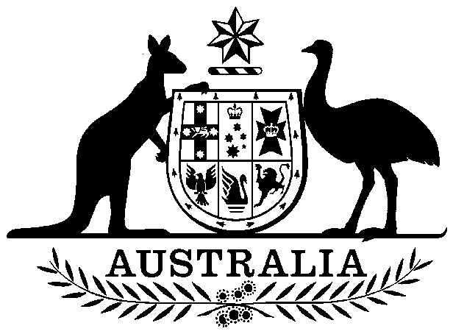

Papua New Guinea Independence Act 1975

No. 98 of 1975

An Act relating to the attainment of Independence by Papua New Guinea

Contents

1 Short title 4

2 Commencement 4

3 Interpretation 4

4 Withdrawal of sovereignty etc. of Australia 4

5 Repeal etc. of laws 4

6 Regulations 4

Schedule 1—Acts repealed 6



Papua New Guinea Independence Act 1975

No. 98 of 1975

An Act relating to the attainment of Independence by Papua New Guinea

[*Assented to 9 September 1975*]

The Parliament of Australia enacts:

WHEREAS certain territories and islands formerly constituting the Possession of British New Guinea and placed by the Crown under the authority of Australia were administered by Australia under the *Papua Act* 1905‑1940 as the Territory of Papua:

AND WHEREAS, in accordance with a Mandate under the Covenant of the League of Nations, certain territories and islands, being former German possessions, were administered by Australia under the *New Guinea Act* 1920‑1935 as the Territory of New Guinea:

AND WHEREAS the Territory of Papua and the Territory of New Guinea were, for a period, administered jointly by Australia under the *Papua‑New Guinea Provisional Administration Act* 1945‑1946:

AND WHEREAS Australia's administration of the Territory of Papua became subject to Chapter XI of the Charter of the United Nations:

AND WHEREAS, in accordance with Chapter XII of that Charter, the General Assembly of the United Nations on 13 December 1946 approved the terms of a Trusteeship Agreement for the Territory of New Guinea, submitted to it by the Government of Australia, in substitution for the terms of the Mandate, which agreement designates the Government of Australia as the sole Authority to exercise the administration of the Territory of New Guinea:

AND WHEREAS the *Papua and New Guinea Act* 1949 provided for the administration of the Territory of Papua and the Territory of New Guinea by Australia in an administrative union, by the name of the Territory of Papua and New Guinea, whilst maintaining the identity and status of the Territory of New Guinea as a Trust Territory and the identity and status of the Territory of Papua as a Possession of the Crown:

AND WHEREAS on 18 November 1963 a House of Assembly was established by the *Papua and New Guinea Act* 1963 to make laws for the peace, order and good government of the Territory of Papua and New Guinea:

AND WHEREAS, by virtue of the *Papua New Guinea Act* 1971, the Territories governed in the administrative union became together known as Papua New Guinea:

AND WHEREAS on 9 July 1974 the House of Assembly resolved that Papua New Guinea move to independent nation status:

AND WHEREAS the General Assembly of the United Nations on 13 December 1974 noted that resolution and resolved that, on the date on which Papua New Guinea became independent, the Trusteeship Agreement would cease to be in force:

AND WHEREAS on 18 June 1975 the House of Assembly nominated 16 September 1975 as the date on which Papua New Guinea is to become independent:

AND WHEREAS on 16 September 1975 Papua New Guinea is to become an independent sovereign state by the name of the Independent State of Papua New Guinea, having a constitution established, adopted and given to themselves by the people of Papua New Guinea acting through their Constituent Assembly:

BE IT THEREFORE ENACTED by the Queen, the Senate and the House of Representatives of Australia, as follows:

##### 1 Short title

This Act may be cited as the *Papua New Guinea Independence Act 1975*.

##### 2 Commencement

This Act shall come into operation on the day on which it receives the Royal Assent.

##### 3 Interpretation

(1) In this Act:

***Independence Day*** means 16 September 1975.

***Papua New Guinea*** has the same meaning as in the *Papua New Guinea Act 1949‑1975*.

(2) In this Act, a reference to an Act or to an Imperial Act includes a reference to an instrument made under an Act or an Imperial Act.

##### 4 Withdrawal of sovereignty etc. of Australia

On the expiration of the day preceding Independence Day, Australia ceases to have any sovereignty, sovereign rights or rights of administration in respect of or appertaining to the whole or any part of Papua New Guinea.

##### 5 Repeal etc. of laws

On the expiration of the day preceding Independence Day:

(a) the Acts specified in the Schedule are repealed; and

(b) every Act, and every Imperial Act, extending to the whole or any part of Papua New Guinea as part of the law of Papua New Guinea ceases so to extend.

##### 6 Regulations

(1) The Governor‑General may make regulations making provision for or in relation to matters arising out of or connected with the attainment of the independence of Papua New Guinea, including regulations making modifications or adaptations of any Act.

(2) Regulations under subsection (1) made before Independence Day shall not have effect before that day.

# Schedule 1—Acts repealed

Section 5

*Papua and New Guinea Act* 1949

*Papua and New Guinea Act* 1954

*Papua and New Guinea Act* 1957

*Papua and New Guinea Act* 1960

*Papua and New Guinea Act (No.*2*)* 1960

*Papua and New Guinea Act* 1963

*Papua and New Guinea Act* 1964

*Papua and New Guinea Act* 1966

*Papua and New Guinea Act* 1968

*Papua and New Guinea Act (No.*2*)* 1968

*Papua and New Guinea Act* 1971

*Papua New Guinea Act* 1971

*Papua New Guinea Act* 1972

*Papua New Guinea Act* 1973

*Papua New Guinea Act (No.*2*)* 1973

*Papua New Guinea Act* 1974

*Papua New Guinea Act (No.*2*)* 1974

*Papua New Guinea Act* 1975