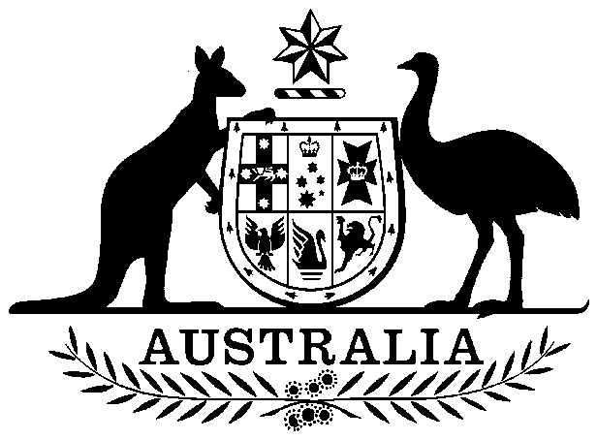

United States Naval Communication Station Agreement Act 1975

No. 102 of 1975

An Act relating to the United States Naval Communication Station established at North West Cape in Western Australia

Contents

1 Short title 2

2 Commencement 2

3 Interpretation 2

4 Approval of Supplemental Agreement 3

Schedule—Amendments of the Principal Agreement 4



United States Naval Communication Station Agreement Act 1975

No. 102 of 1975

An Act relating to the United States Naval Communication Station established at North West Cape in Western Australia

[*Assented to 10 September 1975*]

The Parliament of Australia enacts:

WHEREAS the Government of Australia and the Government of the United States of America, on 9 May 1963, entered into an agreement relating to the establishment of a United States Naval Communication Station in Australia:

AND WHEREAS by the *United States Naval Communication Station Agreement Act* 1963 approval was given to that agreement:

AND WHEREAS by Notes exchanged on 21 March 1974 on behalf of the Government of Australia and the Government of the United States of America it was agreed that:

(a) the agreement dated 9 May 1963 be amended as specified in the Notes; and

(b) the amending agreement should be subject to approval by the two Governments and should enter into force on the date of exchange of instruments notifying such approval:

AND WHEREAS on 14 January 1975 the Government of Australia and the Government of the United States of America exchanged instruments notifying approval of the amending agreement:

AND WHEREAS it is desirable that the amending agreement should be approved by the Parliament:

BE IT THEREFORE ENACTED by the Queen, the Senate and the House of Representatives of Australia, as follows:

##### 1 Short title

This Act may be cited as the *United States Naval Communication Station Agreement Act* 1975.

##### 2 Commencement

This Act shall come into operation on the day on which it receives the Royal Assent.

##### 3 Interpretation

In this Act:

***Principal Agreement*** means the agreement set out in the Schedule to the *United States Naval Communication Station Agreement Act* 1963.

***Supplemental Agreement*** means the agreement constituted by the Notes exchanged, on 21 March 1974, on behalf of the Government of Australia and the Government of the United States of America by which it was agreed that the Principal Agreement be amended as set out in the Schedule.

##### 4 Approval of Supplemental Agreement

The Supplemental Agreement is approved.

# Schedule—Amendments of the Principal Agreement

Section 3

1. Article 1 be amended to read:

“In accordance with the terms and conditions set out in this Agreement, the United States Government may establish, maintain and operate a Naval Communication Station (in this Agreement called the “Station”) at North West Cape in the State of Western Australia. The Station shall be operated by the armed forces of the two Governments as a joint facility.”.

2. Article 2 be amended to read:

“The Australian Government will acquire such land as is required for the purposes of the Station. All land so acquired will remain vested in the Australian Government, which will for the duration of this Agreement grant to the United States Government all necessary rights of access to such land, and of exclusive use and occupancy thereof subject to the provisions of articles 1 and 4.”.

3. Article 14 be amended to read:

“Except as otherwise provided in this Agreement, the construction, maintenance and operation of the Station will be without cost to the Australian Government (other than costs incurred directly by the Australian Government on behalf of its armed forces). The Australian Government will reimburse the United States Government for such expenses as the co-operating agencies of the two Governments agree should be met by Australia for the use of the Station by its forces.”.