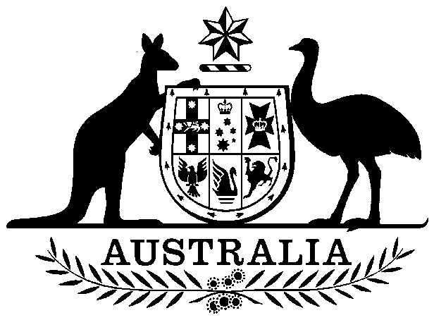

International Financial Institutions (Share Increase) Act 1982

No. 7 of 1982

An Act relating to the purchase of additional shares of the capital stock of the International Bank for Reconstruction and Development and of the International Finance Corporation

Contents

1 Short title 1

2 Commencement 2

3 Interpretation 2

4 Agreements for purchase of additional shares of capital stock of the Bank 2

5 Agreements for purchase of additional shares of capital stock of the Corporation 2

6 Agreements subject to terms and conditions 2

7 Appropriation and issue of securities 3



International Financial Institutions (Share Increase) Act 1982

No. 7 of 1982

An Act relating to the purchase of additional shares of the capital stock of the International Bank for Reconstruction and Development and of the International Finance Corporation

[*Assented to 30 March 1982*]

##### 1 Short title

This Act may be cited as the *International Financial Institutions (Share Increase) Act 1982*.

##### 2 Commencement

This Act shall come into operation on the day on which it receives the Royal Assent.

##### 3 Interpretation

In this Act, unless the contrary intention appears:

***Bank*** means the International Bank for Reconstruction and Development established under the Articles of Agreement set out in Schedule 2 to the *International Monetary Agreements Act 1947*.

***Corporation*** means the International Finance Corporation established under the Articles of Agreement set out in the First Schedule to the *International Finance Corporation Act 1955*.

##### 4 Agreements for purchase of additional shares of capital stock of the Bank

The Treasurer may, on behalf of Australia, make an agreement or agreements with the Bank for the purchase by Australia of 6,287 additional shares of the capital stock of the Bank at a price per share that is the equivalent of 100,000 United States dollars, being dollars in the currency of the United States of America of the weight and fineness that was in effect on 1 July 1944.

##### 5 Agreements for purchase of additional shares of capital stock of the Corporation

The Treasurer may, on behalf of Australia, make an agreement or agreements with the Corporation for the purchase by Australia of 9,976 additional shares of the capital stock of the Corporation at a price per share of 1,000 United States dollars or their equivalent in any other freely convertible currency.

##### 6 Agreements subject to terms and conditions

Subject to this Act, an agreement referred to in section 4 or 5 may contain such terms and conditions as the Treasurer determines.

##### 7 Appropriation and issue of securities

(1) There may be paid out of the Consolidated Revenue Fund, which is appropriated accordingly, the moneys necessary for the purpose of making any payment to be made by Australia in pursuance of an agreement made under section 4 or section 5.

(2) Section 7 of the *International Monetary Agreements Act 1947* applies to any payment to be made by Australia in pursuance of an agreement made under section 4 as it applies to payments under that Act.