Parliamentary Precincts Act 1988
No. 9 of 1988

An Act relating to the precincts of the new Parliament House, and to amend the Parliament Act 1974, the Parliament House Construction Authority Act 1979 and the Parliamentary Privileges Act 1987
[Assented to 5 April 1988]
BE IT ENACTED by the Queen, and the Senate and the House of Representatives of the Commonwealth of Australia, as follows:
Short title
1. This Act may be cited as the Parliamentary Precincts Act 1988.
Commencement
2. (1) Sections 1, 2, 3, 4 and 7, and the amendment of the Parliament House Construction Authority Act 1979 made by this Act, commence on the day on which this Act receives the Royal Assent.
(2) The remaining provisions of this Act commence on a day or days to be fixed by Proclamation.

Interpretation
3. (1) In this Act, unless the contrary intention appears:
“House” means a House of the Parliament;
“order” means a standing or other order, and includes a rule or resolution;
“Parliament House” means the new Parliament House;
“precincts” means:
(a) the Parliamentary precincts defined by section 4; and
(b) any property to which section 5 applies;
“Presiding Officer” means the President of the Senate or the Speaker of the House of Representatives;
“property” means:
(a) land; or
(b) a building or part of a building;
“protective service officer” means:
(a) a protective service officer; or
(b) a special protective service officer;
within the meaning of the Australian Protective Service Act 1987.
(2) A reference in this Act to a Presiding Officer includes a reference to a person for the time being exercising powers, and performing functions, vested in a Presiding Officer apart from this Act.
(3) A reference in this Act to the Presiding Officers is a reference to those Officers acting jointly.
Parliamentary precincts
4. (1) The Parliamentary precincts consist of the land on the inner side of the boundary defined by subsection (2), and all buildings, structures and works, and parts of buildings, structures and works, on, above or under that land.
(2) The boundary of the Parliamentary precincts is the approximately circular line comprising:
(a) the arcs formed by the outer edge of the top of the retaining wall; and
(b) in places where there is no retaining wall—arcs completing the circle partly formed by the first-mentioned arcs.
(3) In this section:
“inner” means nearer to Parliament House, and “outer” has the opposite meaning;
“retaining wall” means the wall of varying height that partly surrounds the perimeter of the site of Parliament House and is near the inner kerb of Capital Circle, but does not include any part of the road tunnel on Capital Circle.

(4) The location of the Parliamentary precincts defined by this section is indicated by shading on the plan set out in Schedule 1.
Premises included in Parliamentary precincts
5. (1) This section applies to property that is owned or held under lease by the Commonwealth and is not within the Parliamentary precincts defined by section 4.
(2) If the Presiding Officers certify in writing that specified property is required for purposes of the Parliament, the regulations may declare that the property shall be treated as part of the Parliamentary precincts for the purposes of this Act.
Control and management of precincts
6. (1) The precincts are under the control and management of the Presiding Officers.
(2) The Presiding Officers may, subject to any order of either House, take any action they consider necessary for the control and management of the precincts.
(3) In respect of the Ministerial Wing in Parliament House, the powers and functions given to the Presiding Officers by subsections (1) and (2) are subject to any limitations and conditions agreed between the Presiding Officers and the Minister.
Leases and licences
7. (1) The Presiding Officers may, on behalf of the Commonwealth:
(a) grant leases and licences in respect of property in the precincts to be used for commercial purposes; and
(b) exercise any rights of the Commonwealth in respect of such leases and licences.
(2) Leases and licences shall be on such terms and conditions, and subject to payment of such consideration, as the Presiding Officers think fit.
(3) This section has effect notwithstanding anything to the contrary in any law of the Australian Capital Territory relating to leases.
(4) In this section:
“precincts” does not include any property to which section 5 applies.
Australian Federal Police
8. (1) Where, under an order of either House relating to the powers, privileges and immunities of that House, a person is required to be arrested or held in custody, the person may be arrested or held by a member or special member of the Australian Federal Police in accordance with general arrangements agreed between the Presiding Officers and the Minister administering the Australian Federal Police Act 1979.
(2) Subsection (1) has effect notwithstanding the Australian Federal Police Act 1979.

Australian Protective Service
9. The functions of protective service officers in relation to the precincts shall be performed in accordance with general arrangements agreed between the Presiding Officers and the Minister administering the Australian Protective Service Act 1987.
Prosecutions
10. The functions of the Director of Public Prosecutions in respect of offences committed in the precincts shall be performed in accordance with general arrangements agreed between the Presiding Officers and the Director of Public Prosecutions.
Public Order (Protection of Persons and Property) Act 1971
11. The Public Order (Protection of Persons and Property) Act 1971 applies to the precincts as if they were Commonwealth premises within the meaning of that Act.
Saving of powers, privileges and immunities
12. Nothing in this Act shall be taken to derogate from the powers, privileges and immunities of each House, and of the members and committees of each House, under any other law.
Regulations
13. The Governor-General may make regulations for the purposes of subsection 5 (2).
Amendments of other Acts
14. The Acts specified in Schedule 2 are amended as set out in that Schedule.
—————

SCHEDULE 1 Section 4
PARLIAMENTARY PRECINCTS
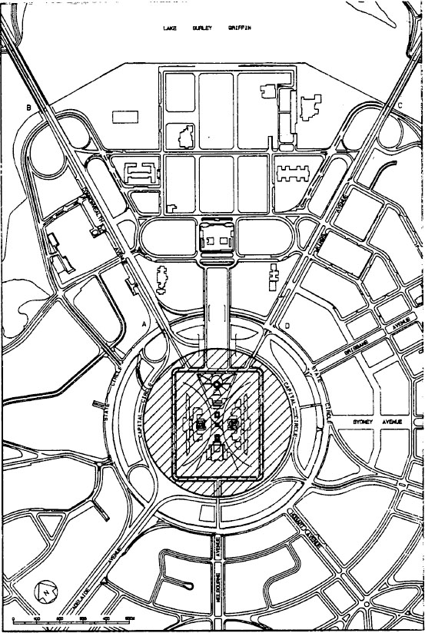
—————

SCHEDULE 2 Section 14
AMENDMENTS OF OTHER ACTS
Parliament Act 1974
Section 3:
Omit the section, substitute the following section:
Parliamentary zone
“3. (1) For the purposes of this Act, the Parliamentary zone is the area of land bounded by a line commencing at a point where the eastern boundary of Commonwealth Avenue intersects the inner boundary of State Circle and proceeding thence in a northerly direction along the eastern boundary of Commonwealth Avenue until it intersects the southern shore of Lake Burley Griffin, thence in a generally easterly direction along that shore until it intersects the western boundary of Kings Avenue, thence in a south westerly direction along that boundary until it intersects the inner boundary of State Circle, and thence clockwise around that inner boundary to the point of commencement.
“(2) The location of the Parliamentary zone is indicated by shading on the plan set out in the Schedule.”.
Section 5:
Omit subsection (1), substitute the following subsection:
“(1) No building or other work is to be erected on land within the Parliamentary zone unless:
(a) if the land is within the precincts as defined by subsection 3 (1) of the Parliamentary Precincts Act 1988—the President of the Senate and the Speaker of the House of Representatives jointly have; or
(b) in any other case—the Minister has;
caused a proposal for the erection of the building or work to be laid before each House of the Parliament and the proposal has been approved by resolution of each House.”.
Schedule:
Omit the Schedule, substitute the Schedule set out in Schedule 3 to this Act.
Parliament House Construction Authority Act 1979
Section 10:
After subsection (2) insert the following subsection:
“(2a) The consent of the Authority is not required for a lease or licence to be granted under section 7 of the Parliamentary Precincts Act 1988.”.

SCHEDULE 2—continued
Parliamentary Privileges Act 1987
Section 15:
Omit all the words after “tenor”, substitute:
“(except as otherwise provided by that or any other law) in relation to:
(a) any building in the Territory in which a House meets; and
(b) any part of the precincts as defined by subsection 3 (1) of the Parliamentary Precincts Act 1988.”.
—————

SCHEDULE 3 Section 14
SCHEDULE TO BE INSERTED IN PARLIAMENT ACT 1974
SCHEDULE Sections 3 and 4
PARLIAMENTARY ZONE
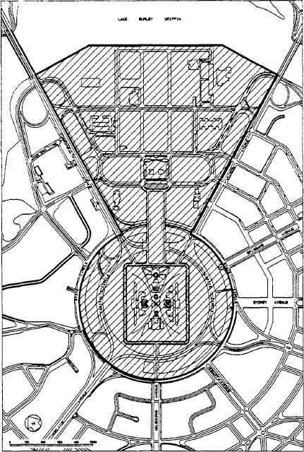

[Minister’s second reading speech made in—
House of Representatives on 18 February 1988
Senate on 15 March 1988]

