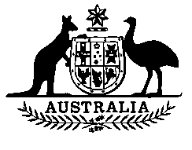

**Wool Marketing Amendment Act 1990**

**No. 62 of 1990**

An Act to amend the ***Wool Marketing Act 1987***

[Assented to 16 June 1990]

BE IT ENACTED by the Queen, and the Senate and the House of Representatives of the Commonwealth of Australia, as follows:

**Short title etc.**

**1**. **(1)** This Act may be cited as the Wool Marketing Amendment Act 1990.

**(2)** In this Act, **“Principal Act”** means the Wool Marketing Act 19871.

**Commencement**

**2**. This Act commences on the day on which it receives the Royal Assent.

**Raising of money by Corporation**

**3**. Section 53 of the Principal Act is amended by inserting after subsection (7) the following subsection:

“(**7**a) The Treasurer, or an officer authorised in writing by the Treasurer for the purpose, may, on behalf of the Commonwealth, guarantee the repayment of money borrowed, or otherwise raised, before 1 July 1992, in accordance with subsection (1) and the payment of interest on money so borrowed or raised.”.

**NOTE**

1. No. 90, 1987, as amended. For previous amendments, see Nos. 51 and 111, 1988; Nos. 88 and 130, 1989; and No. 16, 1990.

[*Minister's second reading speech made in*—

*House of Representatives on 1 June 1990*

*Senate on 1 June 1990*]