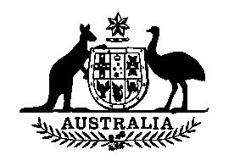

**Wool Tax (No. 4) Amendment Act 1990**

No. 66 of 1990

An Act to amend the **Wool Tax Act (No. 4) 1964**, and for related purposes

[Assented to 16 June 1990]

BE IT ENACTED by the Queen, and the Senate and the House of Representatives of the Commonwealth of Australia, as follows:

**Short title etc.**

**1.** **(1)** This Act may be cited as the Wool Tax (No. 4) Amendment Act 1990.

**(2)** In this Act, **“Principal Act”** means the *Wool Tax Act (No. 4) 1964*1.

**Commencement**

**2**. This Act commences on the day on which it receives the Royal Assent.

**Rate of Tax**

**3**. Section 5 of the Principal Act is amended by omitting from paragraph (a) “10” and substituting “20”.

**Application**

**4.** Regulations made for the purposes of section 5 of the Principal Act as amended by this Act may be expressed to apply to all shorn wool on which a tax is imposed under section 4 of the Principal Act as so amended, being shorn wool subjected by a manufacturer to a process of manufacture after 30 June 1990 or such later day as is from time to time specified in the regulations.

**NOTE**

1. No. 28, 1964, as amended. For previous amendments, see No. 67, 1973; No. 69, 1974; No. 89, 1975; Nos. 37 and 75, 1976; No. 47, 1977; No. 75, 1978; No. 35, 1979; No. 54, 1980; No. 88, 1985; and No. 49, 1987.

[Minister’s second reading speech made in—

House of Representatives on 17 May 1990

Senate on 1 June 1990]