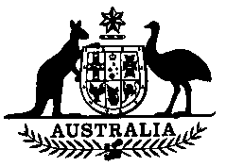

**Airlines Agreement (Termination) Act 1990**

**No. 73 of 1990**

An Act relating to the termination of an air transport agreement

[Assented to 24 September 1990]

BE IT ENACTED by the Queen, and the Senate and the House of Representatives of the Commonwealth of Australia, as follows:

**Short title**

**1.** This Act may be cited as the Airlines Agreement (Termination) Act 1990.

**Commencement**

**2.** This Act commences on 31 October 1990.

**Repeal of Acts**

**3.** The following Acts are repealed:

Airlines Agreement Act 1981

Airlines Equipment Act 1958

Independent Air Fares Committee Act 1981.

**Amendments consequential on section 3**

**4.** The Acts specified in the Schedule are amended as set out in it.

——————

**SCHEDULE** Section 4

AMENDMENTS CONSEQUENTIAL ON SECTION 3

**Australian Airlines (Conversion to Public Company) Act 1988**

**Section 59:**

Repeal the section.

**Federal Airports Corporation Act 1986**

**Subsection** **70 (2):**

Omit the subsection.

**Inter-State Commission Act 1975**

**Section 6:**

Repeal the section.

————————————————--—————————————————————————

[*Minister's second reading speech made in*—

*House of Representatives on 31 May 1990*

Senate on 23 August 1990]