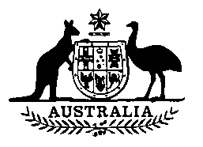

**Dried Fruits Levy Amendment Act 1990**

**No. 74 of 1990**

**An Act to amend the *Dried Fruits Levy Act 1971***

[Assented to 18 October 1990]

BE IT ENACTED by the Queen, and the Senate and the House of Representatives of the Commonwealth of Australia, as follows:

**Short title etc.**

**1. (1)** This Act may be cited as the Dried Fruits Levy Amendment Act 1990.

**(2)** In this Act, **“Principal Act”** means the Dried Fruits Levy Act 1971¹.

**Commencement**

**2.** This Act commences on the day on which it receives the Royal Assent.

**Rate of Levy**

**3.** Section 6 of the Principal Act is amended by omitting from paragraph (1) (a) “$5.00” and substituting “$10.00”.

**NOTE**

1. No. 19, 1971. as amended. For previous amendments, see No. 72, 1975; No. 37, 1976; No. 29, 1984; No. 103, 1985; and No. 22, 1986.

[Minister's second reading speech made in—

House of Representatives on 22 August 1990

Senate on 9 October 1990]