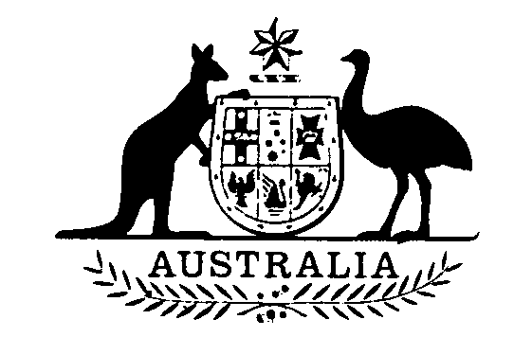

**National Residue Survey (Coarse Grains) Levy Act 1992**

**No. 246 of 1992**

**An Act to impose National Residue Survey Levy in respect of coarse grains**

[*Assented to 24 December 1992*]

The Parliament of Australia enacts:

**Short title**

**1.** This Act may be cited as the *National Residue Survey (Coarse Grains) Levy Act 1992.*

**Commencement**

**2.** This Act commences on 1 July 1993.

**Interpretation**

**3.** In this Act:

**"coarse grain"** means leviable coarse grain within the meaning of the *Coarse Grains Levy Act 1992.*

**Act binds Crown**

**4.** This Act binds the Crown in right of each of the States, of the Australian Capital Territory, of the Northern Territory and of Norfolk Island.

**Imposition of levy**

**5.** National Residue Survey Levy, within the meaning of the *National Residue Survey Administration Act 1992*,to the extent that it is payable in respect of coarse grains, is imposed by this Act.

[*Minister's second reading speech made in*—

*House of Representatives on 3 November 1992*

*Senate on 10 November 1992*]