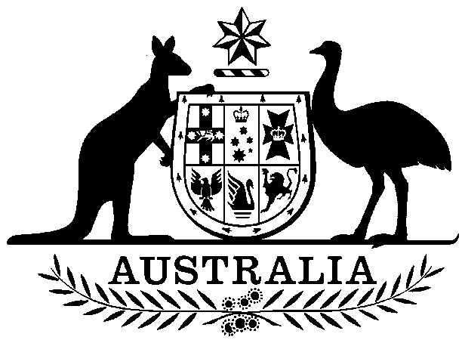

Nuclear Safeguards (Producers of Uranium Ore Concentrates) Charge Act 1993

No. 34 of 1993

An Act to impose a charge on certain persons producing uranium ore concentrates

Contents

1 Short title 1

2 Commencement 2

3 Imposition of charge 2



Nuclear Safeguards (Producers of Uranium Ore Concentrates) Charge Act 1993

No. 34 of 1993

An Act to impose a charge on certain persons producing uranium ore concentrates

[*Assented to 20 September 1993*]

The Parliament of Australia enacts:

##### 1 Short title

This Act may be cited as the *Nuclear Safeguards (Producers of Uranium Ore Concentrates) Charge Act 1993*.

##### 2 Commencement

This Act commences on 1 November 1993.

##### 3 Imposition of charge

A charge is imposed on a person who, on 1 November in a financial year, holds a permit to possess an unlimited quantity of uranium ore concentrates granted under paragraph 13(1)(a) of the *Nuclear Non-Proliferation (Safeguards) Act 1987* if:

(a) during the previous financial year the person produced more than 1,000 kilograms of uranium ore concentrates at a processing facility; and

(b) at any time (whether during the previous financial year or earlier) the person, or another person, exported uranium ore concentrates produced at that processing facility.