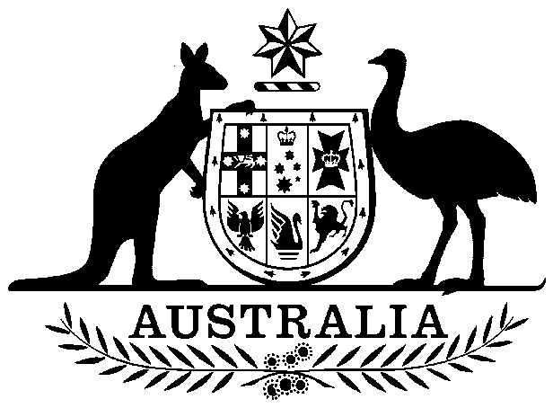

Agricultural and Veterinary Chemical Products Levy Imposition (Excise) Act 1994

No. 38, 1994

An Act to impose the levy payable under the Agricultural and Veterinary Chemical Products (Collection of Levy) Act 1994, so far as that levy is a duty of excise

Contents
1 Short title 2
2 Commencement 2
3 Imposition 2
4 Act does not impose levy on property of a State 2

Agricultural and Veterinary Chemical Products Levy Imposition (Excise) Act 1994
No. 38, 1994

An Act to impose the levy payable under the Agricultural and Veterinary Chemical Products (Collection of Levy) Act 1994, so far as that levy is a duty of excise
[Assented to 15 March 1994]
The Parliament of Australia enacts:

1 Short title
This Act may be cited as the Agricultural and Veterinary Chemical Products Levy Imposition (Excise) Act 1994.

2 Commencement
This Act commences on the same day as the Agricultural and Veterinary Chemicals Act 1994.

3 Imposition
(1) The levy that is payable under the Agricultural and Veterinary Chemical Products (Collection of Levy) Act 1994 is imposed by this section.
(2) This section imposes the levy only so far as the levy is a duty of excise within the meaning of section 55 of the Constitution.

4 Act does not impose levy on property of a State
(1) This Act does not impose a levy on property of any kind belonging to a State.
(2) In this section, property of any kind belonging to a State has the same meaning as in section 114 of the Constitution.

