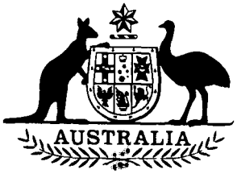

**Horticultural Export Charge  
Amendment Act 1994**

**No. 114 of 1994**

**An Act to amend the *Horticultural Export Charge Act 1987*,and for related purposes**

[*Assented to 16 September 1994*]

The Parliament of Australia enacts:

**Short title etc.**

**1.(1)** This Act may be cited as the *Horticultural Export Charge Amendment Act 1994.*

**(2)** In this Act, **“Principal Act”** means the *Horticultural Export Charge Act 1987*1.

**Commencement**

**2.** This Act commences on the day on which the *Horticultural Levy Amendment Act 1994* commences.

**Repeal and substitution of section 13**

**3.(1)** Section 13 of the Principal Act is repealed and the following section is substituted:

**Exemptions from charge**

“13.(1) Charge is not payable on chargeable horticultural products if the producer has paid levy on those horticultural products.

“(2) The regulations may exempt from charge:

(a) chargeable horticultural products exported by a specified class of persons; or

(b) specified subclasses of a class of chargeable horticultural products.”.

**(2)** Despite the repeal of section 13 of the Principal Act made by subsection (1), the regulations made for the purposes of that section that were in force immediately before its repeal continue in force after that repeal as if those regulations had been made for the purposes of subsection 13(2) of the Principal Act as amended by this Act.



**NOTE**

1**.** No. 170, 1987, as amended. For previous amendments, see No. 48, 1989; Nos. 26 and 42, 1991.

[*Minister’s second reading speech made in*—

*House of Representatives on 24 August 1994*

*Senate on 25 August 1994*]