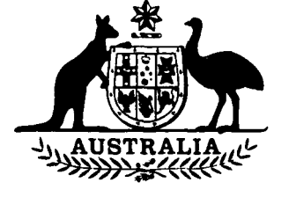

**Australian Trade Commission  
Amendment Act 1994**

**No. 127 of 1994**

**An Act to amend the *Australian Trade Commission Act 1985***

[*Assented to 18 October 1994*]

The Parliament of Australia enacts:

**Short title etc.**

**1.(1)** This Act may be cited as the *Australian Trade Commission Amendment Act 1994.*

**(2)** In this Act, **“Principal Act”** means the *Australian Trade Commission Act 1985*1.

**Commencement**

**2.** This Act commences on the day on which it receives the Royal Assent.

**Membership of Board**

**3.** Section 12 of the Principal Act is amended by omitting subsections (6), (7) and (8).



**NOTE**

1. No. 186, 1985, as amended. For previous amendments, see No. 168, 1986; No. 141, 1987; Nos. 21, 91 and 129, 1989; and Nos. 122, 149 and 199, 1991.

[*Minister’s second reading speech made in*—

*Senate on 11 May 1994*

*House of Representatives on 13 October 1994*]