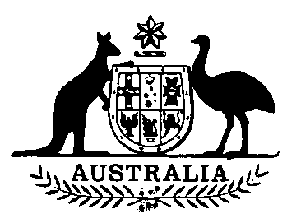

**National Residue Survey Administration  
(Meat Chickens) Amendment  
Act 1994**

**No. 128 of 1994**

**An Act to increase the maximum rate of national residue  
survey levy in relation to meat chickens**

[*Assented to 21 October 1994*]

The Parliament of Australia enacts:

**Short title etc.**

**1.(1)** This Act may be cited as the *National Residue Survey Administration (Meat Chickens) Amendment Act 1994.*

**(2)** In this Act, **“Principal Act”** means the *National Residue Survey Administration Act 1992*1.

**Commencement**

**2.** This Act commences on the day on which it receives the Royal Assent.

**Amendment of Schedule**

**3.** The Schedule to the Principal Act is amended by omitting from column 3 of the table “0.02 cents per head” where those words appear opposite the reference to meat chickens in column 1 of the table and substituting “0.06 cents per head”.



**NOTE**

1. No. 243, 1992.

[*Minister’s second reading speech made in*—

*House of Representatives on 22 September 1994*

*Senate on 10 October 1994*]