Hindmarsh Island Bridge Act 1997

No. 60, 1997

An Act to facilitate the construction of the Hindmarsh Island bridge, and for related purposes

Contents
1 Short title 1
2 Commencement 1
3 Interpretation 2
4 Provisions facilitating construction etc. of the bridge 2
Schedule 1—Description of areas 3

Hindmarsh Island Bridge Act 1997
No. 60, 1997

An Act to facilitate the construction of the Hindmarsh Island bridge, and for related purposes
[Assented to 22 May 1997]
The Parliament of Australia enacts:

1 Short title
This Act may be cited as the Hindmarsh Island Bridge Act 1997.

2 Commencement
This Act commences on the day on which it receives the Royal Assent.

3 Interpretation
In this Act:
Heritage Protection Act means the Aboriginal and Torres Strait Islander Heritage Protection Act 1984.
Hindmarsh Island bridge area means the area identified in clause 1 of Schedule 1.
pit area means the area identified in clause 2 of Schedule 1.

4 Provisions facilitating construction etc. of the bridge
(1) The Heritage Protection Act does not authorise the making of a declaration in relation to the preservation or protection of an area or object from any of the following activities:
(a) the construction of a bridge, and associated works (including approaches to the bridge), in the Hindmarsh Island bridge area;
(b) work or other activities in that area preparatory to, or associated with, that construction;
(c) maintenance on, or repairs to, the bridge and associated works;
(d) use of the bridge and associated works;
(e) the removal of materials from, or dumping of materials in, the pit area in connection with any of the activities mentioned in paragraphs (a), (b) and (c).
(2) The Heritage Protection Act does not authorise the Minister to take any action after the commencement of this Act in relation to an application (whether made before or after the commencement of this Act) that relates (wholly or partly) to activity covered by paragraph (1)(a), (b), (c), (d) or (e).

Schedule 1—Description of areas

1 Hindmarsh Island bridge area
For the purposes of this Act, the Hindmarsh Island bridge area is the area of land and water in South Australia, County of Hindmarsh, Hundreds of Goolwa and Nangkita, bounded as follows (coordinate references are to Australian Map Grid Coordinates (AMG 84) Zone 54):
(a) from 299000 East 6068870 North, a straight line south-east to 299650 East 6068360 North;
(b) then from that point, a straight line south-west to 299629 East 6068270 North;
(c) then from that point, a straight line north-west to 298959 East 6068750 North;
(d) then from that point, a straight line back to the starting point.
A map of the area appears on the next page. The description above is authoritative and prevails over the map if there is any inconsistency.

2 Pit area
For the purposes of this Act, the pit area is the area of land in the State of South Australia, County of Hindmarsh, Hundred of Nangkita, bounded as follows (coordinate references are to Australian Map Grid Coordinates (AMG 84) Zone 54):
(a) from 300440 East 6067790 North, a straight line in a grid North direction to meet the southern boundary of the road reserve known as Randell Road;
(b) then generally in a north-westerly direction for 300 metres along that boundary;
(c) then a straight line generally in a south-westerly direction to 300065 East 6067780 North;
(d) then from that point, a straight line back to the starting point.

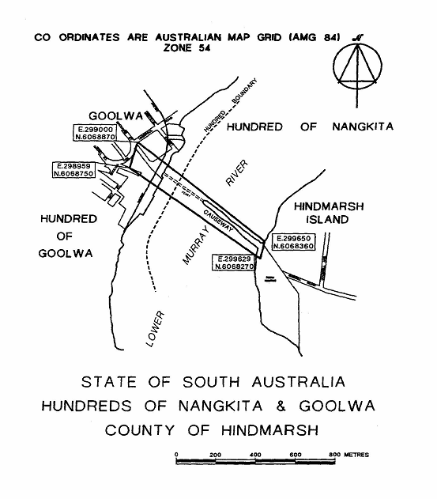

[Minister’s second reading speech made in—
House of Representatives on 17 October 1996
Senate on 18 November 1996]

(139/96)

I HEREBY CERTIFY that the above is a fair print of the Hindmarsh Island Bridge Bill 1997 which originated in the House of Representatives as the Hindmarsh Island Bridge Bill 1996 and has been finally passed by the Senate and the House of Representatives.

Clerk of the House of Representatives

IN THE NAME OF HER MAJESTY, I assent to this Act.

Governor-General
1997

