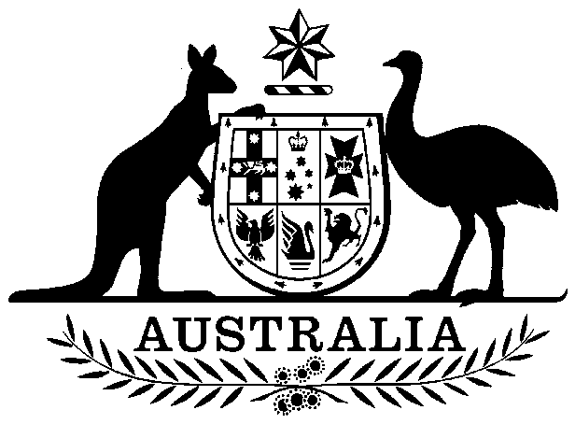

National Residue Survey (Sheep, Lambs and Goats Transactions) Levy Act 1997

No. 221, 1997

National Residue Survey (Sheep, Lambs and Goats Transactions) Levy Act 1997

No. 221, 1997

An Act to impose National Residue Survey Levy in respect of certain transactions and other dealings involving sheep, lambs and goats, and for purposes dealing with the imposition of the levy

Contents
1 Short title
2 Commencement
3 Definitions
4 Act binds the Crown
5 Imposition of levy
6 Rates of levy
7 Who pays the levy
8 Regulations

National Residue Survey (Sheep, Lambs and Goats Transactions) Levy Act 1997
No. 221, 1997

An Act to impose National Residue Survey Levy in respect of certain transactions and other dealings involving sheep, lambs and goats, and for purposes dealing with the imposition of the levy
[Assented to 17 December 1997]
The Parliament of Australia enacts:

1 Short title
This Act may be cited as the National Residue Survey (Sheep, Lambs and Goats Transactions) Levy Act 1997.

2 Commencement
This Act commences at the commencement of Part 3 of the Australian Meat and Live-stock Industry Act 1997.

3 Definitions
(1) In this Act, unless the contrary intention appears:
lamb means a sheep that has not cut a permanent incisor tooth.
sheep does not include lambs.
slaughter means slaughter for human consumption.
transaction or other dealing, in relation to sheep, lambs or goats, means:
(a) a transaction under which the ownership of the sheep, lambs or goats is transferred; or
(b) the delivery of the sheep, lambs or goats to a processor; or
(c) the slaughter of the sheep, lambs or goats.
(2) Unless the contrary intention appears, a word or expression has the same meaning in this Act as it has in the Primary Industries Levies and Charges Collection Act 1991.

4 Act binds the Crown
This Act binds the Crown in right of each of the States, of the Australian Capital Territory, of the Northern Territory and of Norfolk Island. However, it does not bind the Crown in right of the Commonwealth.

5 Imposition of levy
National Residue Survey Levy is imposed on a transaction or other dealing with sheep, lambs or goats entered into or occurring after the commencement of this Act if levy is payable on that transaction or dealing with the sheep, lambs or goats under the Live-stock Transactions Levy Act 1997.

6 Rates of levy
(1) The rate of levy imposed by this Act in respect of a transaction or other dealing with each head of sheep or lambs is 2 cents or, if another amount (not exceeding 8 cents) is prescribed by the regulations, the other amount.
(2) The rate of levy imposed by this Act in respect of a transaction or other dealing with each head of goats is 3 cents or, if another amount (not exceeding 8 cents) is prescribed by the regulations, the other amount.

7 Who pays the levy
The National Residue Survey Levy imposed by this Act on a transaction or other dealing with sheep, lambs or goats is payable by the person who is liable to pay levy under the Live-stock Transactions Levy Act 1997 on that transaction or other dealing with the sheep, lambs or goats.

8 Regulations
The Governor-General may make regulations prescribing any matters:
(a) required or permitted by this Act to be prescribed; or
(b) necessary or convenient to be prescribed for carrying out or giving effect to this Act.
[Minister's second reading speech made in the⎯
House of Representatives on 1 October 1997
Senate on 29 October 1997]

(158/97)

