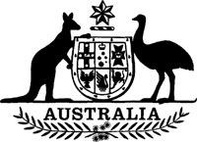
Statutory Rules 1987 No. 256¹
–––––––
Conciliation and Arbitration Regulations² (Amendment)
I, THE ADMINISTRATOR of the Government of the Commonwealth of Australia, acting with the advice of the Federal Executive Council, hereby make the following Regulation under the Conciliation and Arbitration Act 1904.
Dated 29 October 1987.
J. A. ROWLAND
Administrator
By His Excellency’s Command,
R. WILLIS
Minister of State for Industrial Relations
––––––––––
Bodies to which definition of “Commonwealth Authority” in subsection 70a (1) of the Act does not apply
Regulation 164aac of the Conciliation and Arbitration Regulations is amended by omitting paragraph (2) (k) and substituting the following paragraphs:
“(k) Federal Airports Corporation;
(l) Qantas Airways Limited;”.

NOTES
1. Notified in the Commonwealth of Australia Gazette on 6 November 1987.
2. Statutory Rules 1956 No. 60 as amended to date. For previous amendments see Note 2 to Statutory Rules 1987 No. 45 and see also Statutory Rules 1987 No. 45.

