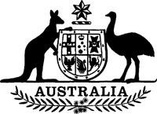
Statutory Rules 1985 No. 81¹
–––––––
Grain (Export Inspection Charge)
Collection Regulations² (Amendment)
I, THE GOVERNOR-GENERAL of the Commonwealth of Australia, acting with the advice of the Federal Executive Council, hereby make the following Regulation under the Grain (Export Inspection Charge) Collection Act 1979.
Dated 23 May 1985.
N. M. STEPHEN
Governor-General
By His Excellency’s Command,
JOHN KERIN
Minister of State for Primary Industry
–––––––––
Repeal
Regulations 7 and 8 of the Grain (Export Inspection Charge) Collection Regulations are repealed.

NOTES
1. Notified in the Commonwealth of Australia Gazette on 30 May 1985.
2. Statutory Rules 1979 No. 100 as amended by 1980 No. 260; 1981 No. 298; 1983 No. 308.

