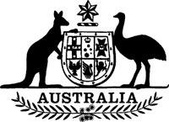
Statutory Rules 1989 No. 247¹
–––––––
Grain Legumes Research Levy Regulations² (Amendment)
I, THE GOVERNOR-GENERAL of the Commonwealth of Australia, acting with the advice of the Federal Executive Council and after taking into consideration the recommendations made to the Minister of State for Primary Industries and Energy by the Grains Council of Australia under subsection 10 (2) of the Grain Legumes Levy Act 1985 with respect to regulations to be made for the purposes of section 7 of that Act, hereby make the following Regulations under that Act.
Dated 28 September 1989.
BILL HAYDEN
Governor-General
By His Excellency’s Command,
PETER COOK
Minister of State for Resources
–––––––––
Commencement
1. These Regulations commence on 1 October 1989.
Rate of levy
2. Regulation 4 of the Grain Legumes Research Levy Regulations is amended by omitting “$1.00” and substituting “$1.25”.

NOTES
1. Notified in the Commonwealth of Australia Gazette on 29 September 1989.
2. Statutory Rules 1988 No. 214.

