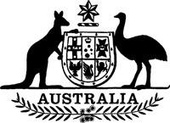
Statutory Rules 1983 No. 236¹
–––––––
Joint Electoral (Commonwealth and New South Wales) Regulations (Repeal)
I, THE GOVERNOR-GENERAL of the Commonwealth of Australia, acting with the advice of the Federal Executive Council, hereby make the following Regulation under the Commonwealth Electoral Act 1918.
Dated 20 October 1983.
N. M. STEPHEN
Governor-General
By His Excellency’s Command,
K. C. BEAZLEY
Special Minister of State
–––––––––
Repeal
Statutory Rules 1930 No. 82 are repealed.

NOTE
1. Notified in the Commonwealth of Australia Gazette on 28 October 1983.

