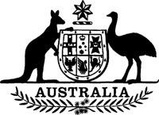
Statutory Rules 1985 No. 282¹
——————
Wheat Tax Regulations (Amendment)
I, THE GOVERNOR-GENERAL of the Commonwealth of Australia, acting with the advice of the Federal Executive Council and after taking into consideration a report made to the Minister of State for Primary Industry by the Australian Wheatgrowers' Federation, hereby make the following Regulations under the Wheat Tax Act 1957.
Dated 31 October 1985.
N. M. STEPHEN
Governor-General
By His Excellency's Command,
JOHN KERIN
Minister of State for Primary Industry
–––––––––––
Commencement
1. These Regulations shall come into operation on 1 November 1985.
Prescribed rate of tax on wheat
2. Regulation 3 of the Wheat Tax Regulations is amended by omitting "30" and Substituting "35".

NOTES
1. Notified in the Commonwealth of Australia Gazette on 31 October 1985.
2. Statutory Rules 1978 No. 191 as amended by 1982 No. 223; 1983 No. 197.

