ELIZABETH R
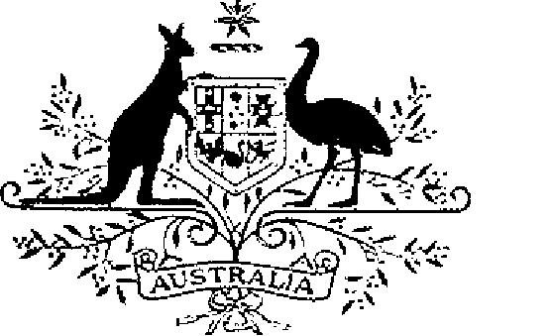

COMMONWEALTH OF AUSTRALIA
ELIZABETH THE SECOND, by the Grace of God Queen of Australia and Her Other Realms and Territories, Head of the Commonwealth:
TO ALL to whom these Presents shall come,
GREETING:
WHEREAS it is desirable that there be instituted certain decorations for the purpose of recognising gallantry in action or outstanding service in warlike operations by units of the Defence Force and by units of the defence forces of other countries:
KNOW YOU that We do by these Presents institute two Australian decorations to be designated and styled, respectively, the Unit Citation for Gallantry and the Meritorious Unit Citation:
AND WE DO ordain that the award of the decorations so instituted shall be governed by the Regulations set out in the Schedule.
IN WITNESS whereof We have caused these Our Letters to be made Patent.
GIVEN under the Great Seal of Australia at Our Court at St James’s on 15 January 1991
By Her Majesty’s Command,
L.S..
BOB HAWKE
Prime Minister

SCHEDULE
UNIT CITATIONS REGULATIONS
Short title
1. These Regulations may be cited as the Unit Citations Regulations.
Interpretation
2. In these Regulations —
“citation” means —
(a) the Unit Citation for Gallantry; or
(b) the Meritorious Unit Citation;
“Defence Force” has the same meaning as in the Defence Act 1903;
“Minister” means the Minister of State for Defence;
“unit” means a unit or sub-unit of the Defence Force or of a defence force of another country.
Conditions for award of citations
3. (1) The Unit Citation for Gallantry shall be awarded to a unit only for acts of extraordinary gallantry in action.
(2) The Meritorious Unit Citation shall be awarded to a unit only for sustained outstanding service in warlike operations.
Form of citations
4. Each citation shall consist of —
(a) a certificate of citation to the unit signed by the Governor-General; and
(b) insignia according to the prescribed design.
Wearing of insignia
5. (1) Each person who was a member of a unit to which a citation is awarded at the time of an action, or during the period to which that citation relates, is entitled to wear the insignia of the citation on all occasions on which the wearing of such insignia is customary.
(2) A person, other than a person to whom sub-regulation (1) applies, who is at any time a member of a unit to which a citation has been awarded is entitled, while the person remains a member of the unit, to wear the insignia of the citation on all occasions on which the wearing of such insignia is customary.
(3) The manner of wearing the insignia of a citation shall be as determined by the Governor-General.
Posthumous awards
6. Insignia of a citation may be awarded posthumously.
Application of Regulations to persons other than members of the Defence Force
7. Where —
(a) a citation is awarded to the unit; and
(b) a person other than a member of the Defence Force was engaged in the performance of services with that unit at the time of the action, or during the period to which that citation relates;
these Regulations apply, on the determination of the Minister, to that person as if the person had been a member of the unit at that time or during the period, as the case may be.
Individual awards not affected
8. Award of a citation to a unit does not affect the making of awards to individual members of the unit in recognition of individual gallantry or service.
Making of awards
9. Awards of a citation shall be made by the Governor-General on the recommendation of the Minister.
Registrar of Awards
10. (1) There shall be a Registrar of Awards appointed by the Governor-General who shall maintain a Register of the names of the units to which citations have been awarded and of the persons to whom insignia of those citations have been issued in accordance with sub-regulation 5 (1).
(2) The Registrar shall keep such other records relating to the award of citations as the Governor-General directs.
Cancellation and reinstatement
11. (1) The Governor-General may cancel the right of a person to wear the insignia of a citation and may reinstate a right so cancelled.
(2) Where the right of a person to wear the insignia of a citation is cancelled, the name of the person shall be erased from the Register and the person shall return the insignia to the Registrar.
(3) Where a right that has been cancelled pursuant to sub-regulation (1) is reinstated, the Registrar shall restore the entry or entries in the Register that had been erased.

