ELIZABETH R
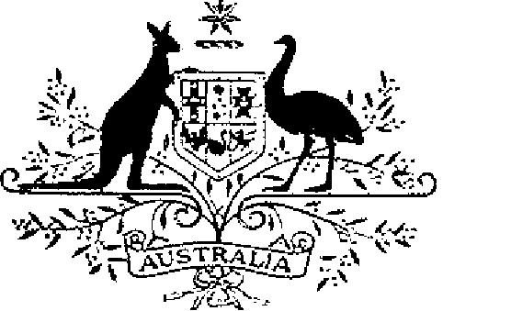

ELIZABETH THE SECOND, by the Grace of God Queen of Australia and Her other Realms and Territories, Head of the Commonwealth:
TO ALL to whom these Presents shall come,
GREETING:
WHEREAS it is desirable that there be instituted certain Australian decorations for the purpose of according recognition to members of the Defence Force and certain other persons for outstanding or meritorious achievement or devotion to duty in non- warlike situations:
KNOW YOU that We do by these Presents institute two decorations to be designated and styled, respectively, the Conspicuous Service Cross and the Conspicuous Service Medal:
AND WE DO ordain that the award of the decorations so instituted shall be governed by the Regulations set out in the Schedule.
IN WITNESS whereof We have caused these Our Letters to be made Patent.
GIVEN under the Great Seal
of Australia at Our Court at St James’s on 18 October 1989
L.S..
By Her Majesty’s Command,
BOB HAWKE
Prime Minister

Schedule
Australian Conspicuous Service Decorations Regulations
Short title
1. These Regulations may be cited as the Australian Conspicuous Service Decorations Regulations.
Interpretation
2. In these Regulations —
“decoration” means:
(a) the Conspicuous Service Cross;
(b) the Conspicuous Service Medal; or
(c) a bar to the Cross or the Medal.
“Defence Force” has the same meaning as in the Defence Act 1903.
“Minister” means the Minister of State for Defence.
Conditions for award of decorations
3. (1) The Conspicuous Service Cross shall be awarded only for outstanding devotion to duty, or outstanding achievement in the application of exceptional skills, judgement or dedication, in non-warlike situations.
(2) The Conspicuous Service Medal shall be awarded for meritorious achievement or devotion to duty, in non-warlike situations.
4. Each decoration may be awarded posthumously.
5. The persons to whom a decoration may be awarded are —
(a) a member of the Defence Force; and
(b) other persons determined by the Minister for the purposes of this regulation.
6. Any subsequent award of the Conspicuous Service Cross or the Conspicuous Service Medal to the same person shall be made in the form of a bar to the Cross or the Medal as the case may be.
Making of awards
7. The award of a decoration shall be made by the Governor-General on the recommendation of the Minister.
Designations
8. (1) A person to whom the Conspicuous Service Cross has been awarded is entitled to have the letters “CSC” placed after the person’s name on all occasions when the use of such letters is customary.
(2) A person to whom the Conspicuous Service Medal has been awarded is entitled to have the letters “CSM” placed after the person’s name on all occasions when the use of such letters is customary.
(3) Where a person has been awarded a bar to a decoration the person is entitled to have placed after the letters prescribed by this Regulation in respect of that decoration the words “and Bar” or the words “and Bars”, as the case may be.
Design of decorations
9. The design of each decoration shall be as prescribed.
Wearing of decorations
10. The manner of wearing of decorations shall be as determined by the Governor-General.
Registrar of Awards
11. (1) There shall be a Registrar of Awards who shall be appointed by the Governor-General and who shall maintain a Register of the names of persons to whom decorations have been awarded.
(2) The Registrar shall keep such other records relating to the award of decorations as the Governor-General directs.
Cancellation and reinstatement
12. (1) The Governor-General may cancel an award of a decoration and may reinstate an award so cancelled.
(2) Where an award of a decoration is cancelled, the name of the person to whom the award was made shall be erased from the Register and the person shall return the decoration to the Registrar.
(3) Where an award that has been cancelled pursuant to sub-regulation (1) is reinstated, the Registrar shall restore the entry or entries in the Register that had been erased.

