ELIZABETH R
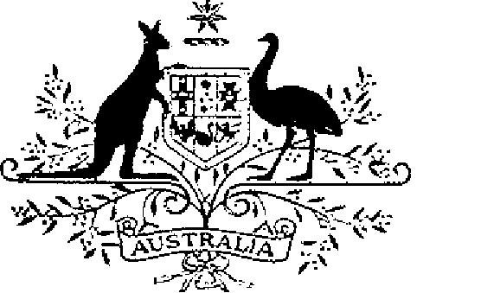

COMMONWEALTH OF AUSTRALIA
ELIZABETH THE SECOND, by the Grace of God Queen of Australia and Her Other Realms and Territories, Head of the Commonwealth:
TO ALL to whom these Presents shall come,
GREETING:
KNOW YOU that it is Our will and pleasure that the Victoria Cross for Australia be the highest decoration for according recognition to persons who, in the presence of the enemy, perform acts of the most conspicuous gallantry, or daring or pre-eminent acts of valour or self-sacrifice or display extreme devotion to duty:
AND WE DO ordain that the award of the Victoria Cross shall be governed by the Regulations set out in the Schedule.
IN WITNESS whereof We have caused these Our Letters to be made Patent.
GIVEN under the Great Seal of Australia at Our Court at St James’s on 15 January 1991

L.S..

By Her Majesty’s Command,
BOB HAWKE
Prime Minister

SCHEDULE
VICTORIA CROSS REGULATIONS
Short title
1. These Regulations may be cited as the Victoria Cross Regulations.
Interpretation
2. In these Regulations —
“decoration” means —
(a) the Victoria Cross; or
(b) a bar to the Victoria Cross;
“Defence Force” has the same meaning as in the Defence Act 1903;
“Minister” means the Minister of State for Defence.
Conditions for award of the decoration
3. The decoration shall only be awarded for the most conspicuous gallantry, or a daring or pre-eminent act of valour or self-sacrifice or extreme devotion to duty in the presence of the enemy.
4. Each decoration may be awarded posthumously.
5. The persons to whom the decoration may be awarded are —
(a) members of the Defence Force; and
(b) other persons determined by the Minister for the purposes of this regulation.
6. Any subsequent award of the Victoria Cross to the same person shall be made in the form of a bar to the Cross.
Making of awards
7. Awards of the decoration shall be made, with the approval of the Sovereign, by Instrument signed by the Governor-General on the recommendation of the Minister.
Designations
8. (1) A person to whom the Victoria Cross has been awarded is entitled to have the letters “VC” placed after the person’s name on all occasions when the use of such letters is customary.
(2) Where a person has been awarded a bar to the Victoria Cross, the person is entitled to have placed after the letters prescribed by sub-regulation (1) the words “and Bar” or the words “and Bars”, as the case may be.
Design of the decoration
9. The design of the decoration shall be as prescribed.
Wearing of the decoration
10. The manner of wearing the decoration shall be as determined by the Governor- General.
Registrar of Awards
11. (1) There shall be a Registrar of Awards appointed by the Governor-General who shall maintain a Register of the names of persons to whom the decoration has been awarded.
(2) The Registrar shall keep such other records relating to the award of the decoration as the Governor-General directs.
Cancellation and reinstatement
12. (1) The Governor-General may cancel an award of the decoration and may reinstate an award so cancelled.
(2) Where an award of the decoration is cancelled, the name of the person to whom the award was made shall be erased from the Register and the person shall return the decoration to the Registrar.
(3) Where an award that has been cancelled pursuant to sub-regulation (1) is reinstated, the Registrar shall restore the entry or entries in the Register that had been erased.

