ELIZABETH R
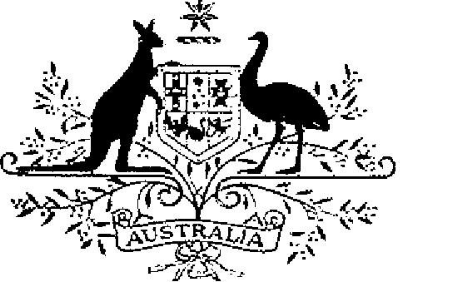

COMMONWEALTH OF AUSTRALIA
ELIZABETH THE SECOND, by the Grace of God Queen of Australia and Her Other Realms and Territories, Head of the Commonwealth:
TO ALL to whom these Presents shall come,
GREETING:
WHEREAS it is desirable that there be instituted certain decorations for the purpose of according recognition to members of the Defence Force and certain other persons who perform acts of gallantry in action:
KNOW YOU that We do by these Presents institute three Australian decorations to be designated and styled, respectively, the Star of Gallantry, the Medal for Gallantry and the Commendation for Gallantry:
AND WE DO ordain that the award of the decorations so instituted shall be governed by the Regulations set out in the Schedule.
IN WITNESS whereof We have caused these Our Letters to be made Patent.
GIVEN under the Great Seal of Australia at Our Court at St James’s on 15 January 1991
By Her Majesty’s Command,
L.S..
BOB HAWKE
Prime Minister

SCHEDULE
GALLANTRY DECORATIONS REGULATIONS
Short title
1. These Regulations may be cited as the Gallantry Decorations Regulations.
Interpretation
2. In these Regulations —
“decoration” means —
(a) the Star of Gallantry;
(b) the Medal for Gallantry;
(c) the Commendation for Gallantry; or
(d) a bar to the Star or Medal;
“Defence Force” has the same meaning as in the Defence Act 1903;
“Minister” means the Minister of State for Defence.
Conditions for award of decorations
3. (1) The Star of Gallantry shall be awarded only for acts of great heroism or conspicuous gallantry in action in circumstances of great peril.
(2) The Medal for Gallantry shall be awarded only for acts of gallantry in action in hazardous circumstances.
(3) The Commendation for Gallantry may be awarded for other acts of gallantry in action which are considered worthy of recognition.
4. Each decoration may be awarded posthumously.
5. The persons to whom a decoration may be awarded are —
(a) members of the Defence Force; and
(b) other persons determined by the Minister for the purposes of this regulation.
6. Any subsequent award of the Star of Gallantry or the Medal for Gallantry to the same person shall be made in the form of a bar to the Star or the Medal, as the case may be.
Making of awards
7. Awards of a decoration shall be made by the Governor-General on the recommendation of the Minister.
Making of immediate awards
8. (1) An immediate award of a decoration may be made by the Governor-General on the recommendation of the Minister.
(2) The Governor-General may delegate the authority to make immediate awards on the recommendation of the Minister.
Designations
9. (1) A person to whom the Star of Gallantry has been awarded is entitled to have the letters “SG” placed after the person’s name on all occasions when the use of such letters is customary.
(2) A person to whom the Medal for Gallantry has been awarded is entitled to have the letters “MG” placed after the person’s name on all occasions when the use of such letters is customary.
(3) Where a person has been awarded a bar to a decoration, the person is entitled to have placed after the letters prescribed by the Regulation in respect of that decoration the words “and Bar” or the words “and Bars”, as the case may be.
Design of decorations
10. The design of each decoration shall be as prescribed.
Wearing of decorations
11. The manner of wearing each decoration shall be as determined by the Governor-General.
Registrar of Awards
12. (1) There shall be a Registrar of Awards appointed by the Governor-General who shall maintain a Register of the names of persons to whom decorations have been awarded.
(2) The Registrar shall keep such other records relating to the award of decorations as the Governor-General directs.
Cancellation and reinstatement
13. (1) The Governor-General may cancel an award of a decoration and may reinstate an award so cancelled.
(2) Where an award of a decoration is cancelled, the name of the person to whom the award was made shall be erased from the Register and the person shall return the decoration to the Registrar.
(3) Where an award that has been cancelled pursuant to sub-regulation (1) is reinstated, the Registrar shall restore the entry or entries in the Register that had been erased.

