ELIZABETH R

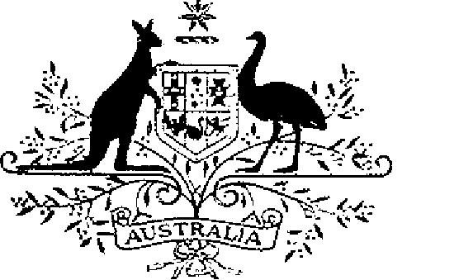

COMMONWEALTH OF AUSTRALIA
ELIZABETH THE SECOND, by the Grace of God, Queen of Australia and Her other Realms and Territories, Head of the Commonwealth:
TO ALL to whom these Presents shall come.
GREETING:
WHEREAS by Letters Patent passed under the Great Seal of Australia, bearing date at St James’s the fourteenth day of February 1975, We did establish a society of honour known as the ‘Order of Australia’ and made other provision with respect to membership and the Constitution of the Order:
AND WHEREAS by Letters Patent passed under the Great Seal of Australia, bearing date at St. James’s the twenty-fourth day of May 1976, We established a new category of membership of the Order, namely, membership as a Knight or Dame of the Order:
AND WHEREAS We are desirous that His Royal Highness Charles, Prince of Wales, be a Knight of the Order having precedence of all Knights and Dames of the Order, other than Our Governor-General of the Commonwealth of Australia:
KNOW YOU that We, by these Presents, declare Our pleasure that the above-mentioned Letters Patent of the fourteenth day of February 1975 be further amended, but without prejudice to anything lawfully done thereunder, as set out in the Schedule:
IN WITNESS whereof We have caused these Our Letters to be made Patent.
GIVEN under the Great Seal of Australia at Our Court at St James’s on 14 March 1981
L.S..
By Her Majesty’s Command,
MALCOLM FRASER
Prime Minister
Schedule
Amendment of the Constitution of the Order of Australia
After section 3 the following section is inserted:
‘3A. His Royal Highness Charles, Prince of Wales, shall be a Knight in the General Division of the Order and shall have precedence of all Knights and Dames of the Order other than the Governor-General of the Commonwealth of Australia’.

