ELIZABETH R
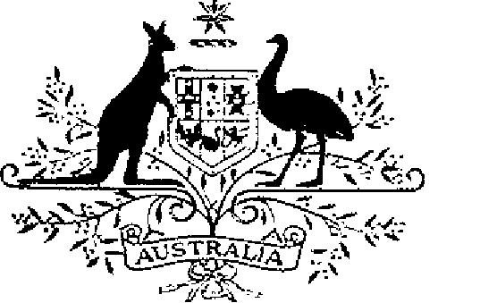

ELIZABETH THE SECOND, by the Grace of God Queen of Australia and Her other Realms and Territories, Head of the Commonwealth:
TO ALL to whom these Presents shall come,
GREETINGS:
WHEREAS by Letters Patent Dated 14 February 1975 We established a society of honour to be known as the “Order of Australia” and made provision with respect to membership and the Constitution of the Order:
AND WHEREAS it is desirable that certain amendments be made to the Constitution of the Order:
KNOW YOU that We do, by these Presents, declare Our pleasure that the above-mentioned Letters Patent dated 14 February 1975, as amended by Letters Patent dated 24 May 1976 and by Letters Patent dated 14 March 1981, be further amended, but without prejudice to anything lawfully done thereunder, as set out in the Schedule:
AND WE DO ordain that the Order shall henceforth consist of the Sovereign, our Governor-General of the Commonwealth of Australia, His Royal Highness Charles, Prince of Wales, and such persons as have been appointed, or shall hereafter be appointed, to the Order:
AND WE DO further ordain that, notwithstanding the amendments to be made to the Constitution of the Order, a person who was a member of the Order immediately before the issue of these Our Letters Patent shall, subject to the Constitution of the Order, remain a member of the Order in the class of membership that the person held at that time:
IN WITNESS whereof We have caused these Our Letters to be made Patent.
GIVEN under the Great Seal of Australia at our Court at Government House, Canberra on 3 March 1986
L.S..

By Her Majesty’s Command,
BOB HAWKE
Prime Minister

Schedule
Amendments of the Constitution of the Order of Australia
1. Section 1 is amended by omitting “Knight or Dame”, from sub-section (3).
2. Section 2 is revoked and the following section substituted:
“2. (1) The Governor-General of the Commonwealth of Australia shall be the Chancellor of the Order.
“(2) Where a person ceases to hold office as Governor-General, he or she shall continue to be a member of the Order in the General Division in the class of membership that he or she held immediately before ceasing to hold that office.”.
3. After section 2 the following section is inserted:
“2A. (1) The Governor-General shall have precedence, after the Sovereign, of all other members of the Order.
“(2) His Royal Highness Charles, Prince of Wales, shall have precedence in the Order immediately after the Governor-General.”.
4. Section 3A is revoked.
5. Section 4 is amended by omitting paragraphs 1 (c), (d) and (e) and substituting the following paragraphs:
“(c) the person for the time being occupying the office of Secretary to the Department of the Special Minister of State or, if another office is prescribed for the purposes of this paragraph, the person occupying the office so prescribed;
(d) the person for the time being occupying the office of Chief of the Defence Force or, if another office is prescribed for the purpose of this paragraph, the person occupying the office so prescribed; and
(e) not more than 14 Persons appointed by the Governor-General of whom-
(i) not more than 6 shall be persons nominated by the States of the Commonwealth of Australia; and
(ii) one may be a person nominated by the Northern Territory of Australia.”
6. Section 9 is amended by omitting all words after “Order” (third occurring).
7. Sections 11A, 11B and 11C, together with the heading immediately before section 11A, are revoked.
8. Section 14 is amended by omitting “twenty” and substituting “25”.
9. Section 16 is amended by omitting “fifty” and substituting “100”.
10. Section 18 is amended by omitting “one hundred and twenty-five” and substituting “225”.
11. Section 18A is amended by adding at the end thereof the following sub-section:
“(2) Awards of the Medal of the Order in the General Division shall not exceed 350 in any calendar year.”.
12. The heading immediately before section 26 is amended by omitting “DESIGNATIONS AND”.
13. Section 26 is revoked.
14. Section 30 is amended by omitting “and (c) investitures.” and substituting the following paragraphs—
“(c) the designations of members of the Order; and
(d) investitures.”.

