ELIZABETH R

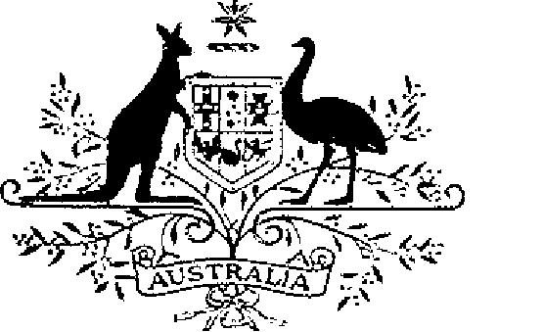

ELIZABETH THE SECOND, by the Grace of God Queen of Australia and Her other Realms and Territories, Head of the Commonwealth:
TO ALL to whom these Presents shall come,
GREETING:
WHEREAS by Letters Patent dated 14 February 1975 We established a society of honour to be known as the “Order of Australia” and made provision with respect to membership and Constitution of the Order:
AND WHEREAS it is desirable that certain amendments be made to the Constitution of the Order:
KNOW YOU that We do, by these Presents, declare Our pleasure that the above-mentioned Letters Patent dated 14 February 1975, as amended by Letters Patent dated 24 May 1976, by Letters Patent dated 14 March 1981, by Letters Patent dated 3 March 1986, by Letters Patent dated 12 April 1988 and by Letters Patent dated 1 February 1989, be further amended, but without prejudice to anything lawfully done thereunder, as set out in the Schedule:
IN WITNESS whereof We have caused these Our Letters to be made Patent.
GIVEN under the Great Seal of Australia at Our Court at St. James’s on 5 December 1991
By Her Majesty’s Command,
L.S..
BOB HAWKE
Prime Minister
Schedule
Amendments to the Constitution of the Order of Australia
1. Section 4 is amended by omitting subparagraph (1) (e) (iii) and substituting the following subparagraph:
“(iii) one may be a person nominated by the Australian Capital Territory.”.

