ELIZABETH R

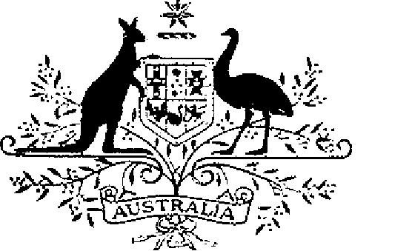

ELIZABETH THE SECOND, by the Grace of God Queen of Australia and Her other Realms and Territories, Head of the Commonwealth:
TO ALL to whom these Presents shall come,
GREETING:
WHEREAS by Letters Patent dated 14 February 1975 We established a society of honour to be known as the “Order of Australia” and made provision with respect to membership and the Constitution of the Order:
AND WHEREAS it is desirable that certain amendments be made to the Constitution of the Order:
KNOW YOU that We do, by these Presents, declare Our pleasure that the abovementioned Letters Patent dated 14 February 1975, as amended by Letters Patent dated 24 May 1976, by Letters Patent dated 14 March 1981, by Letters Patent dated 3 March 1986, by Letters Patent dated 12 April 1988, by Letters Patent dated 1 February 1989, and by Letters Patent dated 5 December 1991, be further amended, but without prejudice to anything lawfully done thereunder, as set out in the Schedule:
IN WITNESS whereof We have caused these Our Letters to be made Patent.
GIVEN under the Great Seal of Australia at Our Court at St. James’s on 24 February 1993
L.S..
By Her Majesty’s Command,
PAUL KEATING
Prime Minister
Schedule
Amendments of the Constitution of the Order of Australia
1. Section 1 is amended by omitting subsections (4) and (5) and substituting the following subsections:
“(4) There shall be a Medal of the Order called the ‘Medal of the Order of Australia’.
“(5) Every Australian citizen appointed to the Order or awarded the Medal of the Order is a member of the Order and every other person appointed to the Order or awarded the Medal of the Order is an honorary member of the Order.”.
2. Section 9 is amended by omitting “as members of” and substituting “to”.
3. Section 24 is amended:
(a) by omitting from subsection (1) “as members of the Order” and substituting “to the Order as members”;
(b) by omitting from subsection (2) “appointments as honorary members of the Order” and substituting “appointments to the Order as honorary members”.
4. Section 25 is amended:
(a) by adding at the end of subsection (1):
“or to be awarded the Medal of the Order”;
(b) by omitting paragraph (c) from subsection (2) and substituting:
“(c) the termination of the appointment of the person to the Order by Ordinance; or
“(d) the cancellation of the award to the person of the Medal of the Order by Ordinance.”;
(c) by omitting subsections (3) and (4) and substituting:
“(3) An appointment that has been terminated, or an award of the Medal of the Order that has been cancelled, may be restored by Ordinance.”.
5. Subsection 28 (2) is amended by omitting “or to be a holder of the Medal of the Order”.

