ELIZABETH R

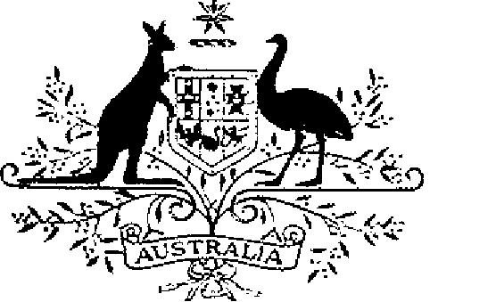

COMMONWEALTH OF AUSTRALIA
ELIZABETH THE SECOND, by the Grace of God Queen of Australia and Her other Realms and Territories, Head of the Commonwealth:
TO ALL to whom these Presents shall come,
GREETING:
WHEREAS by Letters Patent dated 14 February 1975 We established a society of honour to be known as the “Order of Australia” and made provision with respect to membership and the Constitution of the Order:
AND WHEREAS it is desirable that certain amendments be made to the Constitution of the Order:
KNOW YOU that We do, by these Presents, declare Our pleasure that the abovementioned Letters Patent dated 14 February 1975, as amended by Letters Patent dated 24 May 1976, by Letters Patent dated 14 March 1981, by Letters Patent dated 3 March 1986, by Letters Patent dated 12 April 1988, by Letters Patent dated 1 February 1989, by Letters Patent dated 5 December 1991 and by Letters Patent dated 24 February 1993, be further amended, but without prejudice to anything lawfully done thereunder, as set out in the Schedule:
IN WITNESS whereof We have caused these Our Letters to be made Patent.
GIVEN under the Great Seal of Australia at Our Court at St James’s on 1 August 1996
By Her Majesty’s Command,
L.S..
JOHN HOWARD
Prime Minister

Schedule
Amendments of the Constitution of the Order of Australia
1. Section 4 is amended by omitting paragraph (1) (a).
2. Section 4 is amended by omitting paragraph (1) (e) and substituting:
“(e) not more than 16 persons appointed by the Governor-General, of whom-
(i) not more than 6 shall be persons nominated by the States of the Commonwealth of Australia; and
(ii) one may be a person nominated by the Australian Capital Territory; and
(iii) one may be a person nominated by the Northern Territory of Australia.” .
3. Section 4 is amended by omitting from subsection (4) “(1) (a), (b),”, and substituting “(1) (b),”.

