ELIZABETH R

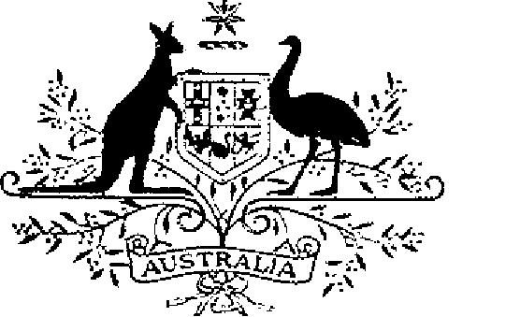

COMMONWEALTH OF AUSTRALIA.
ELIZABETH THE SECOND, by the Grace of God Queen of Australia and Her other Realms and Territories, Head of the Commonwealth:
TO ALL to whom these Presents shall come,
GREETING:
WHEREAS, by Letters Patent dated 14 February 1975, We established a society of honour to be known as the “Order of Australia” and made provision with respect to membership and the Constitution of the Order:
AND WHEREAS it is desirable that certain amendments be made to the Constitution of the Order:
KNOW YOU that We do, by these Presents, declare Our pleasure that the abovementioned Letters Patent dated 14 February 1975, as amended by Letters Patent dated 24 May 1976, by Letters Patent dated 14 March 1981, by Letters Patent dated 3 March 1986, by Letters Patent dated 12 April 1988, by Letters Patent dated 1 February 1989, by Letters Patent dated 5 December 1991, by Letters Patent dated 24 February 1993 and by Letters Patent dated 1 August 1996, be further amended, but without prejudice to anything lawfully done thereunder, as set out in the Schedule:
IN WITNESS whereof We have caused these Our Letters to be made Patent.
GIVEN under the Great Seal of Australia at Our Court at St James’s on 5 March, 1998
By Her Majesty’s Command,
L.S..
JOHN HOWARD
Prime Minister
Schedule
Amendments of the Constitution of the Order of Australia
1. Section 4
1.1 Paragraph 4 (1) (c):
Omit the paragraph, substitute:
“(c) the person for the time being occupying, or performing the duties of, the office prescribed for the purposes of this paragraph by the Minister responsible for the administration of the Australian honours system or any Minister or member of the Executive Council acting for or on behalf of that Minister; and”.
1.2 Paragraph 4 (1) (e):
Omit the paragraph, substitute:
“(e) 16 persons appointed by the Governor-General, of whom:
(i) 8 shall be nominated by the Prime Minister; and
(ii) one shall be nominated by the State of New South Wales; and
(iii) one shall be nominated by the State of Victoria; and
(iv) one shall be nominated by the State of Queensland; and
(v) one shall be nominated by the State of Western Australia; and
(vi) one shall be nominated by the State of South Australia; and
(vii) one shall be nominated by the State of Tasmania; and
(viii) one shall be nominated by the Northern Territory of Australia; and
(ix) one shall be nominated by the Australian Capital Territory.”.
1.3 Subsection 4 (3):
Omit the subsection, substitute:
“(3) The Governor-General shall:
(a) on the recommendation of the Prime Minister, appoint one of the members appointed under subparagraph (1) (e) (i) to be Chairman of the Council; and
(b) in the event of the Chairman being unavailable to act in the office, appoint another member appointed under subparagraph (1) (e) (i) to act as Chairman of the Council.”.
1.4 Subsection 4 (4):
Omit the subsection, substitute:
“(4) If a member of the Council is absent or unable to act in that capacity, the member may be represented on the Council:
(a) if the member is the Vice-President of the Federal Executive Council—by another member of the Federal Executive Council under summons chosen, in accordance with arrangements made by the Governor-General, to act in the member’s place as a member of the Council; or

(b) if the member is a member referred to in paragraph (1) (c) or (d) or subparagraph (1) (e) (ii), (iii), (iv), (v), (vi), (vii), (viii) or (ix)—by a person chosen, in accordance with arrangements made by the Governor-General, to act in the member’s place as a member of the Council.”.
2. New section 5A
2.1 After section 5, insert:
“5A (1) 10 members of the Council constitute a quorum for the transaction of the business of the Council.
“(2) In this section, ‘member of the Council’ includes a person chosen to act, under subsection 4 (4), in the place of a member mentioned in paragraph 4 (1) (b), (c), (d) or (e).”.
3. Section 19
3.1 Omit “19”, substitute “19 (1)”.
3.2 Add at the end:
“(2) Upon the recommendation of the Prime Minister, appointments to the Order as honorary members in the General Division may be made by the Governor-General.”.
4. Section 20
4.1 Subsection 20 (1):
Omit the subsection, substitute:
“(1) The following are eligible to be appointed to the order as members in the Military Division:
(a) members of the Defence Force; and
(b) former members of the Defence Force whose Defence Force service has ceased for not more than one year; and
(c) other persons determined by the Minister for Defence for the purposes of this paragraph.”,
4.2 Subsection 20 (4):
Omit the subsection, substitute:
“(4) The Medal of the Order in the Military Division may be awarded to:
(a) members of the Defence Force; and
(b) former members of the Defence Force whose Defence Force service has ceased for not more than one year; and
(c) other persons determined by the Minister for Defence for the purposes of this paragraph.”,
5. Section 24
5.1 Omit the section, substitute:
“24 (1) Upon the recommendation of the Minister for Defence, appointments to the Order as members in the Military Division and awards of the Medal of the Order in the Military Division may be made by the Governor-General.
“(2) Upon the recommendation of the Minister for Defence, appointments to the Order as honorary members in the Military Division may be made by the Governor-General.” .
6. Section 30
6.1 Omit “prescribed or are necessary or convenient to be prescribed for carrying out or giving effect to this Constitution, and, in particular, prescribing matters for or in relation to –“, substitute "prescribed, or necessary or convenient to be prescribed for carrying out or giving effect to this Constitution and, in particular, prescribing matters for:”
6.2 Paragraph 30 (d):
Omit “investitures.”, substitute “investitures; and”.
6.3 Add at the end:
“(e) terminations and cancellations.”.

