ELIZABETH R

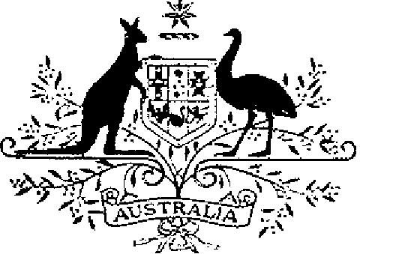

COMMONWEALTH OF AUSTRALIA
ELIZABETH THE SECOND, by the Grace of God Queen of Australia and Her other Realms and Territories, Head of the Commonwealth:
TO ALL to whom these Presents shall come,
GREETING:
WHEREAS by Letters Patent dated 14 February 1975, We established a society of honour to be known as the “Order of Australia” and made provision with respect to the membership and the Constitution of the Order.
AND WHEREAS it is desirable that certain amendments be made to the Constitution of the Order:
KNOW YOU that We do, by these Presents, declare Our pleasure that the abovementioned Letters Patent dated 14 February 1975, as amended by Letters Patent dated 24 May 1976, by Letters Patent dated 14 March 1981, by Letters Patent dated 3 March 1986, by Letters Patent dated 12 April 1988, by Letters Patent dated 1 February 1989, by Letters Patent dated 5 December 1991, by Letters Patent dated 24 February 1993, by Letters Patent dated 1 August 1996 and by Letters Patent dated 5 March 1998, be further amended, but without prejudice to anything lawfully done thereunder, as set out in the Schedule:
IN WITNESS whereof We have caused these Our Letters to be made Patent.
GIVEN under the Great Seal of Australia at Our Court at St James’s, on 30 April 2003
L.S..
By Her Majesty’s Command
JOHN HOWARD
Prime Minister
Schedule
Amendments of the Constitution of the Order of Australia
[1] Section 14
omit
25
insert
30
[2] Section 16
omit
100
insert
125
[3] Section 18
omit
225
insert
300

