ELIZABETH R
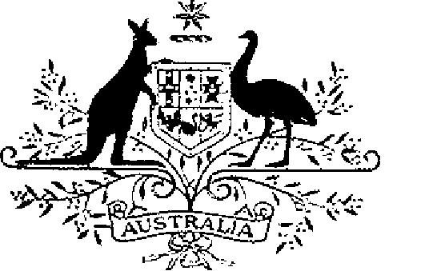

ELIZABETH THE SECOND, by the Grace of God Queen of Australia and Her other Realms and Territories, Head of the Commonwealth:
TO ALL to whom these Presents shall come,
GREETING:
WHEREAS it is desirable that there be instituted an Australian medal for the purpose of encouraging skill in a small arms shooting in the Defence Force:
KNOW YOU that We do by these Presents institute a medal to be designated and styled the Champion Shots Medal:
AND WE DO ordain that the award of the Champion Shots Medal shall be governed by the Regulations set out in the Schedule.
IN WITNESS whereof We have caused these Our Letters to be made Patent.
GIVEN under the Great Seal of Australia at Our Court at St James’s on 13 September 1988
L.S..
By Her Majesty’s Command,
BOB HAWKE
Prime Minister

SCHEDULE
CHAMPION SHOTS MEDAL REGULATIONS
Short title
1. These Regulations may be cited as the Champion Shots Medal Regulations.
Interpretation
2. In these Regulations:
“clasp” means a device to denote the year of the award;
“Defence Force” has the same meaning as in the Defence Force Act 1903;
“Medal” means the Champion Shots Medal.
Conditions for award of the Medal
3. (1) Not more than three Medals may be awarded in a calendar year.
(2) The Medal may be awarded to:
(a) the member of the Royal Australian Navy who has been selected as the Champion Shot of the Royal Australian Navy for that calendar year in a competition conducted under the direction of the Chief of Naval Staff;
(b) the member of the Australian Army who has been selected as the Champion Shot of the Australian Army for that calendar year in a competition conducted under the direction of the Chief of the General Staff;
(c) the member of the Royal Australian Air Force who has been selected as the Champion Shot of the Royal Australian Air Force for that calendar year in a competition conducted under the direction of the Chief of the Air Staff;
(3) Any subsequent award of the Medal to the same person shall be made in the form of a further clasp to the Medal.
Making of awards
4. Awards of the Medal shall be made by the Governor-General on the recommendation of the Chief of the Defence Force or his delegate.
Design of the Medal
5. The design of the Medal shall be as prescribed.
Wearing of the Medal
6. The manner of wearing the Medal shall be as determined by the Governor- General.
Registrar of Awards
7. (1) There shall be a Registrar of Awards who shall be appointed by the Governor-General and shall maintain a Register of the names of persons to whom the Medal has been awarded.
(2) The Registrar shall keep such other records relating to the award of the Medal as the Governor-General directs.
Cancellation and reinstatement
8. (1) The Governor-General may cancel the award of the Medal and may reinstate an award so cancelled.
(2) Where an award of the Medal is cancelled, the name of the person to whom the award was made shall be erased from the Register and the person shall return the Medal to the Registrar.
(3) Where an award that has been cancelled pursuant to sub-regulation (1) is reinstated, the Registrar shall restore the entry or entries in the Register that has been erased.

