ELIZABETH R
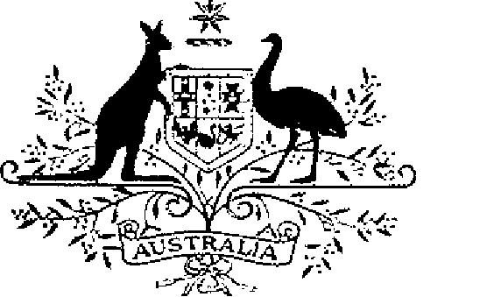

ELIZABETH THE SECOND, by the Grace of God Queen of Australia and Her Other Realms and Territories, Head of the Commonwealth:
TO ALL to whom these Presents shall come,
GREETING:
WHEREAS it is desirable that there be instituted an Australian medal for the purpose of according recognition to members of Australian police forces for distinguished service:
KNOW YOU that we do by these Presents institute a medal to be designated and styled the Australian Police Medal:
AND WE DO ordain that the award of the medal so instituted shall be governed by the Regulations Governing the Award of the Australian Police Medal set out in the Schedule.
IN WITNESS whereof We have caused these Our Letters to be made Patent.
GIVEN under the Great Seal of Australia at Our Court at Government House, Canberra on 3 March 1986

L.S..

By Her Majesty’s Command,
BOB HAWKE
Prime Minister

Schedule
Regulations Governing the Award of the Australian Police Medal
Short title
1. These Regulations may be cited as the Australian Police Medal Regulations.
Interpretation
2. In these Regulations—
“Australian police force” means the Australian Federal Police or the police force of a State or Territory of the Commonwealth;
“Medal” means the Australian Police Medal.
Design of Medal
3. The design of the Medal shall be as prescribed.
Conditions for award of Medal
4. (1) The Medal shall be awarded only for distinguished service by a member of an Australian police force.
(2) The Medal shall not be awarded to a member of a police force if the award would result in the number of awards made during a calendar year to members of that force exceeding one award for each thousand, or part of one thousand, members of that force serving on 30 June in the year immediately preceding that calendar year, together with one additional Medal.
Awards
5. (1) An award of the Medal shall be made by the Governor-General and notified in the Commonwealth of Australia Gazette.
(2) The Medal shall not be awarded to a member of a police force except upon the nomination of the responsible Minister for that force.
(3) For the purpose of sub-regulation (2), the responsible Minister for a police force is—
(a) in the case of the Australian Federal Police—the Minister of State of the Commonwealth administering the Australian Federal Police Act 1979 or a Minister of State of the Commonwealth acting for and on behalf of the first-mentioned Minister;
(b) in the case of the Police Force of a State—the Premier of that State or a Minister of the Crown of that State acting for and on behalf of the Premier; and
(c) in the case of the Police Force of a Territory—the Chief Minister of that Territory or a Minister of that Territory acting for and on behalf of the Chief Minister.
Wearing of the Medal
6. The manner of wearing the Medal shall be as determined by the Governor-General.
Designation of holder of Medal
7. Persons to whom the Medal has been awarded are entitled to have the letters “APM” placed after their names on all occasions when the use of such letters is customary.
Register of awards
8. (1) There shall be a Registrar of Awards who shall be appointed by the Governor-General and shall maintain a register of the names of persons to whom the Medal has been awarded.
(2) The Registrar shall keep such other records relating to the award of the Medal as the Governor-General directs.
Cancellation and reinstatement
9. (1) The Governor-General may cancel the award of the Medal to a person and may restore an award so cancelled.
(2) Where an award of the Medal is cancelled, the name of the person to whom the award was made shall be erased from the Register kept for the purpose of regulation 8 and that person shall return the Medal to the Registrar.
(3) Where an award that has been cancelled is restored, the Registrar shall restore the entry in the Register that had been erased.

