ELIZABETH R
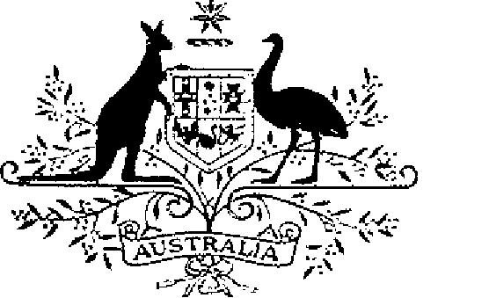

ELIZABETH THE SECOND, by the Grace of God Queen of Australia and Her other Realms and Territories, Head of the Commonwealth:
TO ALL to whom these Presents shall come,
GREETING:
WHEREAS by Letters Patent dated 12 April 1988 We instituted an Australian medal to be known as the "Australian Fire Service Medal" and made provision with respect to Regulations Governing the Award of the Australian Fire Service Medal:
AND WHEREAS it is desirable that certain amendments be made to the Regulations:
KNOW YOU that We do, by these Presents, declare Our pleasure that the above-mentioned Letters Patent dated 12 April 1988 be amended, but without prejudice to anything lawfully done thereunder, as set out in the Schedule:
IN WITNESS whereof We have caused these Our Letters to be made Patent.
GIVEN under the Great Seal of Australia at Our Court at St James’s on 5 December 1991

L.S..

By Her Majesty’s Command,
BOB HAWKE
Prime Minister
Schedule
Amendments to the Regulations Governing the Award of the Australian Fire Service Medal
1 Regulation 2 is amended by omitting paragraph (c) of the definition of “responsible Minister” and substituting the following paragraph:
“(c) in the case of a fire service of the Australian Capital Territory—the Chief Minister of that Territory or a Minister of that Territory acting for and on behalf of the Chief Minister;”.

